SADC AVIATION SAFETY ORGANIZATION (SASO)
REGULATIONS


AERONAUTICAL METEOROLOGICAL SERVICE

First Edition
Month 2023

Page intentionally left blank

LIST OF EFFECTIVE PAGES
Page  No. | Rev.  No. | Date

Table of Contents
LIST OF EFFECTIVE PAGES 2
RECORD OF REVISIONS 8
PART I 9
CHAPTER 1 9
PRELIMINARY PROVISIONS 9
MET.001. [ARTICLE CODE] Citation and commencement 9
MET.002. [Article code] Application 9
PART II 10
CHAPTER 2 10
GENERAL PROVISIONS 10
MET.003. Objective, determination and provision of meteorological service 10
MET.004. Supply, use, quality management and interpretation of meteorological information 10
MET.005. Notifications required from operators 10
CHAPTER 3 12
GLOBAL SYSTEMS, SUPPORTING CENTRES AND METEOROLOGICAL OFFICES 12
MET.006. World area forecast system 12
MET.007. World area forecast centres 12
MET.008. Aerodrome meteorological offices 12
MET.009. Meteorological watch offices 12
MET.010. Volcanic ash advisory centres 13
MET.011. Space weather centres 13
CHAPTER 4 14
METEOROLOGICAL OBSERVATIONS AND REPORTS 14
MET.012. Aeronautical meteorological stations and observations 14
MET.013. Routine observations and reports 14
MET.014. Special observations and reports 14
MET.015. Contents of reports 15
MET.016. Observing and reporting meteorological elements 15
MET.017. Reporting meteorological information from automatic observing systems 16
CHAPTER 5 17
AIRCRAFT OBSERVATIONS AND REPORTS 17
MET.018. Types of aircraft observations 17
MET.019. Routine aircraft observations — designation 17
MET.020. Routine aircraft observations — exemptions 17
MET.021. Special aircraft observations 17
MET.022. Other non-routine aircraft observations 17
MET.023. Reporting of aircraft observations during flight 18
MET.024. Relay of air-reports by air traffic services units 18
MET.025. Recording and post-flight reporting of aircraft observations of volcanic activity 18
CHAPTER 6. 19
FORECASTS 19
MET.026. Use of forecasts 19
MET.027. Aerodrome forecasts 19
MET.028. Landing forecasts 19
MET.029. Forecasts for take-off 20
MET.030. Area forecasts for low-level flights 20
CHAPTER 7. 21
SIGMET AND AIRMET INFORMATION, AERODROME WARNINGS AND WIND SHEAR WARNINGS AND ALERTS 21
MET.031. SIGMET information 21
MET.032. AIRMET information 21
MET.033. Aerodrome warnings 21
MET.034. Wind shear warnings and alerts 21
CHAPTER 8. 23
AERONAUTICAL CLIMATOLOGICAL INFORMATION 23
MET.035. General provisions 23
MET.036. Copies of meteorological observational data 23
CHAPTER 9. 24
SERVICE FOR OPERATORS AND FLIGHT CREW MEMBERS 24
MET.037. General provisions 24
MET.038. Briefing, consultation and display 25
MET.039. Flight documentation 26
MET.040. Automated pre-flight information systems for briefing, consultation, flight planning and flight documentation 26
MET.041. Information for aircraft in flight 26
CHAPTER 10. 28
INFORMATION FOR AIR TRAFFIC SERVICES, SEARCH AND RESCUE SERVICES AND AERONAUTICAL INFORMATION SERVICES 28
MET.042. Information for air traffic services units 28
MET.043. Information for search and rescue services units 28
MET.044. Information for aeronautical information services units 28
CHAPTER 11. 29
REQUIREMENTS FOR AND USE OF COMMUNICATIONS 29
MET.045. Requirements for communications 29
MET.046. Use of aeronautical fixed service communications and the public Internet — meteorological bulletins 29
MET.047. Use of aeronautical mobile service communications 29
MET.048. Use of aeronautical data link service — contents of D-VOLMET 29
MET.049. Use of aeronautical broadcasting service contents of VOLMET broadcasts 30
APPENDIX 1. 31
FLIGHT DOCUMENTATION — MODEL CHARTS AND FORMS 31
APP 1-1 31
APP 1-2 32
APP 1-3 33
APP 1-4 34
APP 1-5 35
APP 1-6 36
APP 1-7 37
APP 1-8 38
APP 1-9 39
APP 1-10 40
APP 1-11 41
APP 1-12 42
APP 1-13 43
APP 1-14 44
APP 1-15 45
APP 1-16 46
APPENDIX 2. 47
TECHNICAL SPECIFICATIONS RELATED TO GLOBAL SYSTEMS, SUPPORTING CENTRES AND METEOROLOGICAL OFFICES 47
MET.050. World Area Forecast System 47
MET.051. Aerodrome Meteorological Offices 49
MET.052. Volcanic Ash Advisory Centres 49
MET.053. Tropical Cyclone Advisory Centres 50
MET.054. Space Weather Centres 50
APPENDIX 3. 61
TECHNICAL SPECIFICATIONS RELATED TO METEOROLOGICAL OBSERVATIONS AND REPORTS 61
MET.055. General criteria related to meteorological reports 61
MET.056. Dissemination of meteorological reports 62
MET.057. Observing and reporting of meteorological elements 63
APPENDIX 4. 83
TECHNICAL SPECIFICATIONS RELATED TO AIRCRAFT OBSERVATIONS AND REPORTS 83
MET.058. Contents of Air-Reports 83
MET.059. Criteria for Reporting 85
MET.060. Exchange of Air-Reports 86
MET.061. Specific provisions related to reporting Wind Shear and Volcanic Ash 86
APPENDIX 5. 89
TECHNICAL SPECIFICATIONS RELATED TO FORECASTS 89
MET.062. Criteria related to TAF 89
MET.063. Criteria related to Trend Forecasts 90
MET.064. Criteria related to area forecasts for low-level flights 92
APPENDIX 6. 99
TECHNICAL SPECIFICATIONS RELATED TO SIGMET AND AIRMET INFORMATION, AERODROME WARNINGS AND WIND SHEAR WARNINGS AND ALERTS 99
MET.065. Specifications related to SIGMET information 99
MET.066. Specifications related to AIRMET information 100
MET.067. Detailed criteria related to SIGMET and AIRMET messages and special air-reports (uplink) 102
MET.068. Specifications related to aerodrome warnings 102
MET.069. Specifications related to wind shear warnings 102
APPENDIX 8. 116
TECHNICAL SPECIFICATIONS RELATED TO SERVICE FOR OPERATORS AND FLIGHT CREW MEMBERS 116
MET.070. Means of supply and format of meteorological information 116
MET.071. Specifications related to information for pre-flight planning and in-flight replanning 116
MET.072. Specifications related to flight documentation 116
MET.073. Specifications related to automated pre-flight information systems for briefing, consultation, flight planning and flight documentation 117
APPENDIX 9. 121
TECHNICAL SPECIFICATIONS RELATED TO INFORMATION FOR AIR TRAFFIC SERVICES, SEARCH AND RESCUE SERVICES AND AERONAUTICAL INFORMATION SERVICES 121
MET.074. Information to be provided for air traffic services units 121
MET.075. Information to be provided for search and rescue services units 122
MET.076. Information to be provided for aeronautical information services units 122
APPENDIX 10. 124
TECHNICAL SPECIFICATIONS RELATED TO REQUIREMENTS FOR AND USE OF COMMUNICATIONS 124
MET.077. Specific requirements for communications 124
MET.078. Use of aeronautical fixed service communications and the public internet 124
MET.079. Use of aeronautical mobile service communications 124
MET.080. Use of aeronautical data link service — D-VOLMET 124
MET.081. Use of aeronautical broadcasting service — VOLMET broadcasts 125

RECORD OF REVISIONS
Rev. No | Date  (DD-MM-YYYY) | Subject | Inserted By  (Department-Division)

PART I

CHAPTER 1

PRELIMINARY PROVISIONS

Citation and commencement
- These Regulations may be cited as the SASO Model Civil Aviation (Aeronautical Meteorological Service) Regulations, 2023
- These regulations come into operation on the date on which it is published in the [State] Gazette.

Application
- These Regulations shall apply to a person providing [Aeronautical Meteorological Service] services within designated air spaces and at aerodromes.

PART II

CHAPTER 2

GENERAL PROVISIONS

Objective, determination and provision of meteorological service
- The objective of meteorological service for international air navigation shall be to contribute towards the safety, regularity and efficiency of international air navigation.
- This objective shall be achieved by supplying the following users: operators, flight crew members, air traffic services units, search and rescue services units, airport managements and others concerned with the conduct or development of international air navigation, with the meteorological information necessary for the performance of their respective functions.

Supply, use, quality management and interpretation of meteorological information
- Close liaison shall be maintained between those concerned with the supply and those concerned with the use of meteorological information on matters which affect the provision of meteorological service for international air navigation.
- Demonstration of compliance of the quality system applied shall be by audit. If non-conformity of the system is identified, action shall be initiated to determine and correct the cause. All audit observations shall be evidenced and properly documented.
- Owing to the variability of meteorological elements in space and time, to limitations of observing techniques and to limitations caused by the definitions of some of the elements, the specific value of any of the elements given in a report shall be understood by the recipient to be the best approximation of the actual conditions at the time of observation.
- Owing to the variability of meteorological elements in space and time, to limitations of forecasting techniques and to limitations caused by the definitions of some of the elements, the specific value of any of the elements given in a forecast shall be understood by the recipient to be the most probable value which the element is likely to assume during the period of the forecast. Similarly, when the time of occurrence or change of an element is given in a forecast, this time shall be understood to be the most probable time.
- The meteorological information supplied to the users listed in [ARTICLE CODE] Objective, determination and provision of meteorological serviceshall be consistent with Human Factors principles and shall be in forms which require a minimum of interpretation by these users, as specified in the following chapters.

Notifications required from operators
- An operator requiring meteorological service or changes in existing meteorological service shall notify, sufficiently in advance, the meteorological authority or the aerodrome meteorological office concerned. The minimum amount of advance notice required shall be as agreed between the meteorological authority or aerodrome meteorological office and the operator concerned.
- The meteorological authority shall be notified by the operator requiring service when:
- new routes or new types of operations are planned;
- changes of a lasting character are to be made in scheduled operations; and
- other changes, affecting the provision of meteorological service, are planned.
Such information shall contain all details necessary for the planning of appropriate arrangements by the meteorological authority.
- The operator or a flight crew member shall ensure that, where required by the meteorological authority in consultation with users, the aerodrome meteorological office concerned is notified:
- of flight schedules;
- when non-scheduled flights are to be operated; and
- when flights are delayed, advanced or cancelled.

CHAPTER 3

GLOBAL SYSTEMS, SUPPORTING CENTRES AND METEOROLOGICAL OFFICES

World area forecast system
The objective of the world area forecast system (WAFS) shall be to supply meteorological authorities and other users with global aeronautical meteorological en-route forecasts in digital form. This objective shall be achieved through a comprehensive, integrated, worldwide and, as far as practicable, uniform system, and in a cost-effective manner, taking full advantage of evolving technologies.

World area forecast centres
In case of interruption of the operation of a WAFC, its functions shall be carried out by the other WAFC.

Aerodrome meteorological offices
- An aerodrome meteorological office shall carry out all or some of the following functions as necessary to meet the needs of flight operations at the aerodrome:
- prepare and/or obtain forecasts and other relevant information for flights with which it is concerned; the extent of its responsibilities to prepare forecasts shall be related to the local availability and use of en-route and aerodrome forecast material received from other offices;
- prepare and/or obtain forecasts of local meteorological conditions;
- maintain a continuous survey of meteorological conditions over the aerodromes for which it is designated to prepare forecasts;
- provide briefing, consultation and flight documentation to flight crew members and/or other flight operations personnel;
- supply other meteorological information to aeronautical users;
- display the available meteorological information;
- exchange meteorological information with other aerodrome meteorological offices; and
- supply information received on pre-eruption volcanic activity, a volcanic eruption or volcanic ash cloud, to its associated air traffic services unit, aeronautical information service unit and meteorological watch office (MWO) as agreed between the meteorological, aeronautical information service and ATS authorities concerned.
- The aerodromes for which landing forecasts are required shall be determined by regional air navigation agreement.
- For an aerodrome without an aerodrome meteorological office located at the aerodrome:
- the meteorological authority concerned shall designate one or more aerodrome meteorological office(s) to supply meteorological information as required; and
- the competent authorities shall establish means by which such information can be supplied to the aerodromes concerned.

Meteorological watch offices
- An MWO shall:
- maintain continuous watch over meteorological conditions affecting flight operations within its area of responsibility;
- prepare SIGMET and other information relating to its area of responsibility;
- supply SIGMET information and, as required, other meteorological information to associated air traffic services units
- disseminate SIGMET information;
- when required by regional air navigation agreement, in accordance with MET.034:
- prepare AIRMET information related to its area of responsibility;
- supply AIRMET information to associated air traffic services units; and
- disseminate AIRMET information;
- supply information received on pre-eruption volcanic activity, a volcanic eruption and volcanic ash cloud for which a SIGMET has not already been issued, to its associated area control centre (ACC)/flight information centre (FIC), as agreed between the meteorological and ATS authorities concerned, and to its associated VAAC as determined by regional air navigation agreement; and
- supply information received concerning the release of radioactive materials into the atmosphere, in the area for which it maintains watch or adjacent areas, to its associated ACC/FIC, as agreed between the meteorological and ATS authorities concerned, and to aeronautical information service units, as agreed between the meteorological and appropriate civil aviation authorities concerned. The information shall comprise location, date and time of the release, and forecast trajectories of the radioactive materials.

Volcanic ash advisory centres
- VAACs shall maintain a 24-hour watch.
- In case of interruption of the operation of a VAAC, its functions shall be carried out by another VAAC or another meteorological centre, as designated by the VAAC Provider concerned.

Space weather centres
- SWXC shall maintain a 24-hour watch.
- In case of interruption of the operation of a SWXC, its functions shall be carried out by another SWXC or another centre, as designated by the SWXC Provider concerned.

CHAPTER 4

METEOROLOGICAL OBSERVATIONS AND REPORTS

Aeronautical meteorological stations and observations
- Aeronautical meteorological stations shall make routine observations at fixed intervals. At aerodromes, the routine observations shall be supplemented by special observations whenever specified changes occur in respect of surface wind, visibility, runway visual range, present weather, clouds and/or air temperature.
- At aerodromes with runways intended for Category II and III instrument approach and landing operations, automated equipment for measuring or assessing, as appropriate, and for monitoring and remote indicating of surface wind, visibility, runway visual range, height of cloud base, air and dew-point temperatures and atmospheric pressure shall be installed to support approach and landing and take-off operations. These devices shall be integrated automatic systems for acquisition, processing, dissemination and display in real time of the meteorological parameters affecting landing and take-off operations. The design of integrated automatic systems shall observe Human Factors principles and include back-up procedures.
- The observations shall form the basis for the preparation of reports to be disseminated at the aerodrome of origin and of reports to be disseminated beyond the aerodrome of origin.

Routine observations and reports
- At aerodromes, routine observations shall be made throughout the 24 hours of each day, unless otherwise agreed between the meteorological authority, the appropriate ATS authority and the operator concerned. Such observations shall be made at intervals of one hour or, if so determined by regional air navigation agreement, at intervals of one half-hour. At other aeronautical meteorological stations, such observations shall be made as determined by the meteorological authority taking into account the requirements of air traffic services units and aircraft operations.
- Reports of routine observations shall be issued as:
- local routine reports, only for dissemination at the aerodrome of origin (intended for arriving and departing aircraft); and
- METAR for dissemination beyond the aerodrome of origin (mainly intended for flight planning, VOLMET broadcasts and D-VOLMET).
- At aerodromes that are not operational throughout 24 hours in accordance with (a), METAR shall be issued prior to the aerodrome resuming operations in accordance with regional air navigation agreement.

Special observations and reports
- A list of criteria for special observations shall be established by the meteorological authority, in consultation with the appropriate ATS authority, operators and others concerned
- Reports of special observations shall be issued as:
- local special reports, only for dissemination at the aerodrome of origin (intended for arriving and departing aircraft); and
- SPECI for dissemination beyond the aerodrome of origin (mainly intended for flight planning, VOLMET broadcasts and D-VOLMET) unless METAR are issued at half-hourly intervals.
- At aerodromes that are not operational throughout 24 hours in accordance with (a), following the resumption of the issuance of METAR, SPECI shall be issued, as necessary

Contents of reports
- Local routine reports, local special reports, METAR and SPECI shall contain the following elements in the order indicated:
- identification of the type of report;
- location indicator;
- time of the observation;
- identification of an automated or missing report, when applicable;
- surface wind direction and speed;
- visibility;
- runway visual range, when applicable;
- present weather;
- cloud amount, cloud type (only for cumulonimbus and towering cumulus clouds) and height of cloud base or, where measured, vertical visibility;
- air temperature and dew-point temperature; and
- QNH and, when applicable, QFE (QFE included only in local routine and special reports).
- Optional elements included under supplementary information shall be included in METAR and SPECI in accordance with regional air navigation agreement.

Observing and reporting meteorological elements
- Surface wind
- The mean direction and the mean speed of the surface wind shall be measured, as well as significant variations of the wind direction and speed, and reported in degrees true and metres per second (or knots), respectively.
- Visibility
- The visibility as defined in Chapter 1 shall be measured or observed and reported in metres or kilometres.
- Runway visual range
- Runway visual range as defined in Chapter 1 shall be assessed on all runways intended for Category II and III instrument approach and landing operations.
- The runway visual range, assessed in accordance with (1) and shall be reported in metres throughout periods when either the visibility or the runway visual range is less than 1 500 m.
- Runway visual range assessments shall be representative of:
- the touchdown zone of the runway intended for non-precision or Category I instrument approach and landing operations;
- the touchdown zone and the mid-point of the runway intended for Category II instrument approach and landing operations; and
- the touchdown zone, the mid-point and stop-end of the runway intended for Category III instrument approach and landing operations.
- The units providing air traffic service and aeronautical information service for an aerodrome shall be kept informed without delay of changes in the serviceability status of the automated equipment used for assessing runway visual range.
- Present weather
- The present weather occurring at the aerodrome shall be observed and reported as necessary. The following present weather phenomena shall be identified, as a minimum: rain, drizzle, snow and freezing precipitation (including intensity thereof), haze, mist, fog, freezing fog and thunderstorms (including thunderstorms in the vicinity).
- Clouds
- Cloud amount, cloud type and height of cloud base shall be observed and reported as necessary to describe the clouds of operational significance. When the sky is obscured, vertical visibility shall be observed and reported, where measured, in lieu of cloud amount, cloud type and height of cloud base. The height of cloud base and vertical visibility shall be reported in metres (or feet).
- Air temperature and dew-point temperature
- The air temperature and the dew-point temperature shall be measured and reported in degrees Celsius.
- Atmospheric pressure
- The atmospheric pressure shall be measured, and QNH and QFE values shall be computed and reported in hectopascals.

Reporting meteorological information from automatic observing systems
- Local routine reports, local special reports, METAR and SPECI from automatic observing systems shall be identified with the word “AUTO”.

CHAPTER 5

AIRCRAFT OBSERVATIONS AND REPORTS

Types of aircraft observations
- The following aircraft observations shall be made:
- routine aircraft observations during en-route and climb-out phases of the flight; and
- special and other non-routine aircraft observations during any phase of the flight

Routine aircraft observations — designation
- In the case of air routes with high-density air traffic (e.g. organized tracks), an aircraft from among the aircraft operating at each flight level shall be designated, at approximately hourly intervals, to make routine observations. The designation procedures shall be in accordance with regional air navigation agreement.
- In the case of the requirement to report during the climb-out phase, an aircraft shall be designated, at approximately hourly intervals, at each aerodrome to make routine observations.

Routine aircraft observations — exemptions
- Aircraft not equipped with air-ground data link shall be exempted from making routine aircraft observations.

Special aircraft observations
- Special observations shall be made by all aircraft whenever the following conditions are encountered or observed:
- moderate or severe turbulence; or
- moderate or severe icing; or
- severe mountain wave; or
- thunderstorms, without hail, that are obscured, embedded, widespread or in squall lines; or
- thunderstorms, with hail, that are obscured, embedded, widespread or in squall lines; or
- heavy duststorm or heavy sandstorm; or
- volcanic ash cloud; or
- pre-eruption volcanic activity or a volcanic eruption; or
- as of 4 November 2021, runway braking action encountered is not as good as reported.

Other non-routine aircraft observations
- When other meteorological conditions not listed under MET.019, e.g. wind shear, are encountered and which, in the opinion of the pilot-in-command, may affect the safety or markedly affect the efficiency of other aircraft operations, the pilot-in-command shall advise the appropriate air traffic services unit as soon as practicable.

Reporting of aircraft observations during flight
- Aircraft observations shall be reported by air-ground data link. Where air-ground data link is not available or appropriate, special and other non-routine aircraft observations during flight shall be reported by voice communications.
- Aircraft observations shall be reported during flight at the time the observation is made or as soon thereafter as is practicable.
- Aircraft observations shall be reported as air-reports.

Relay of air-reports by air traffic services units
- The meteorological authority concerned shall make arrangements with the appropriate ATS authority to ensure that, on receipt by the air traffic services units of:
- special air-reports by voice communications, the air traffic services units relay them without delay to their associated meteorological watch office; and
- routine and special air-reports by data link communications, the air traffic services units relay them without delay to their associated meteorological watch office, the WAFCs and the centres designated by regional air navigation agreement for the operation of aeronautical fixed service Internet-based services.

Recording and post-flight reporting of aircraft observations of volcanic activity
- Special aircraft observations of pre-eruption volcanic activity, a volcanic eruption or volcanic ash cloud shall be recorded on the special air-report of volcanic activity form. A copy of the form shall be included with the flight documentation provided to flights operating on routes which, in the opinion of the meteorological authority concerned, could be affected by volcanic ash clouds.

CHAPTER 6.

FORECASTS

Use of forecasts
- The issue of a new forecast by an aerodrome meteorological office, such as a routine aerodrome forecast, shall be understood to cancel automatically any forecast of the same type previously issued for the same place and for the same period of validity or part thereof.

Aerodrome forecasts
- An aerodrome forecast shall be prepared, in accordance with regional air navigation agreement, by the aerodrome meteorological office designated by the meteorological authority concerned.
- An aerodrome forecast shall be issued at a specified time not earlier than one hour prior to the beginning of its validity period and consist of a concise statement of the expected meteorological conditions at an aerodrome for a specified period.
- Aerodrome forecasts and amendments thereto shall be issued as TAF and include the following information in the order indicated:
- identification of the type of forecast;
- location indicator;
- time of issue of forecast;
- identification of a missing forecast, when applicable;
- date and period of validity of forecast;
- identification of a cancelled forecast, when applicable;
- surface wind;
- visibility;
- weather;
- cloud; and
- expected significant changes to one or more of these elements during the period of validity.
Optional elements shall be included in TAF in accordance with regional air navigation agreement.
- Aerodrome meteorological offices preparing TAF shall keep the forecasts under continuous review and, when necessary, shall issue amendments promptly. The length of the forecast messages and the number of changes indicated in the forecast shall be kept to a minimum.
- TAF that cannot be kept under continuous review shall be cancelled.
- When issuing TAF, aerodrome meteorological offices shall ensure that not more than one TAF is valid at an aerodrome at any given time.

Landing forecasts
- A landing forecast shall be prepared by the aerodrome meteorological office designated by the meteorological authority concerned as determined by regional air navigation agreement; such forecasts are intended to meet the requirements of local users and of aircraft within about one hour’s flying time from the aerodrome.
- Landing forecasts shall be prepared in the form of a trend forecast.
- A trend forecast shall consist of a concise statement of the expected significant changes in the meteorological conditions at that aerodrome to be appended to a local routine report, local special report, METAR or SPECI. The period of validity of a trend forecast shall be 2 hours from the time of the report which forms part of the landing forecast.

Forecasts for take-off
- A forecast for take-off shall be prepared by the aerodrome meteorological office designated by the meteorological authority concerned as agreed between the meteorological authority and the operators concerned.

Area forecasts for low-level flights
- When the density of traffic operating below flight level 100 (or up to flight level 150 in mountainous areas, or higher, where necessary) warrants the routine issue and dissemination of area forecasts for such operations, the frequency of issue, the form and the fixed time or period of validity of those forecasts and the criteria for amendments thereto shall be determined by the meteorological authority in consultation with the users.
- When the density of traffic operating below flight level 100 warrants the issuance of AIRMET information in accordance with MET.032, area forecasts for such operations shall be prepared in a format as agreed between the meteorological authorities concerned. When abbreviated plain language is used, the forecast shall be prepared as a GAMET area forecast, employing approved ICAO abbreviations and numerical values; when chart form is used, the forecast shall be prepared as a combination of forecasts of upper wind and upper-air temperature, and of SIGWX phenomena. The area forecasts shall be issued to cover the layer between the ground and flight level 100 (or up to flight level 150 in mountainous areas, or higher, where necessary) and shall contain information on en-route weather phenomena hazardous to low-level flights, in support of the issuance of AIRMET information, and additional information required by low-level flights.
- Area forecasts for low-level flights prepared in support of the issuance of AIRMET information shall be issued every 6 hours for a period of validity of 6 hours and transmitted to meteorological watch offices and/or aerodrome meteorological offices concerned not later than one hour prior to the beginning of their validity period.

CHAPTER 7.

SIGMET AND AIRMET INFORMATION, AERODROME WARNINGS AND WIND SHEAR WARNINGS AND ALERTS

SIGMET information
- SIGMET information shall be issued by a meteorological watch office and shall give a concise description in abbreviated plain language concerning the occurrence or expected occurrence of specified en-route weather and other phenomena in the atmosphere that may affect the safety of aircraft operations, and of the development of those phenomena in time and space.
- SIGMET information shall be cancelled when the phenomena are no longer occurring or are no longer expected to occur in the area.
- The period of validity of a SIGMET message shall be not more than 4 hours. In the special case of SIGMET messages for volcanic ash cloud and tropical cyclones, the period of validity shall be extended up to 6 hours
- Close coordination shall be maintained between the meteorological watch office and the associated area control centre/flight information centre to ensure that information on volcanic ash included in SIGMET and NOTAM messages is consistent.
- SIGMET messages shall be issued not more than 4 hours before the commencement of the period of validity. In the special case of SIGMET messages for volcanic ash cloud and tropical cyclones, these messages shall be issued as soon as practicable but not more than 12 hours before the commencement of the period of validity. SIGMET messages for volcanic ash and tropical cyclones shall be updated at least every 6 hours

AIRMET information
- AIRMET information shall be issued by a meteorological watch office in accordance with regional air navigation agreement, taking into account the density of air traffic operating below flight level 100. AIRMET information shall give a concise description in abbreviated plain language concerning the occurrence and/or expected occurrence of specified en-route weather phenomena, which have not been included in Section I of the area forecast for low-level flights issued in accordance with Chapter 6, MET.028 and which may affect the safety of low-level flights, and of the development of those phenomena in time and space.
- AIRMET information shall be cancelled when the phenomena are no longer occurring or are no longer expected to occur in the area.
- The period of validity of an AIRMET message shall be not more than 4 hours

Aerodrome warnings
- Aerodrome warnings shall be issued by the aerodrome meteorological office designated by the meteorological authority concerned and shall give concise information of meteorological conditions which could adversely affect aircraft on the ground, including parked aircraft, and the aerodrome facilities and services.

Wind shear warnings and alerts
- Wind shear warnings shall be prepared by the aerodrome meteorological office designated by the meteorological authority concerned for aerodromes where wind shear is considered a factor, in accordance with local arrangements with the appropriate air traffic services unit and the operators concerned. Wind shear warnings shall give concise information on the observed or expected existence of wind shear which could adversely affect aircraft on the approach path or take-off path or during circling approach between runway level and 500 m (1 600 ft) above that level and aircraft on the runway during the landing roll or take-off run. Where local topography has been shown to produce significant wind shears at heights in excess of 500 m (1 600 ft) above runway level, then 500 m (1 600 ft) shall not be considered restrictive.
- At aerodromes where wind shear is detected by automated, ground-based, wind shear remote-sensing or detection equipment, wind shear alerts generated by these systems shall be issued. Wind shear alerts shall give concise, up-to-date information related to the observed existence of wind shear involving a headwind/tailwind change of 7.5 m/s (15 kt) or more which could adversely affect aircraft on the final approach path or initial take-off path and aircraft on the runway during the landing roll or take-off run.

CHAPTER 8.

AERONAUTICAL CLIMATOLOGICAL INFORMATION

General provisions
- Aeronautical climatological information required for the planning of flight operations shall be prepared in the form of aerodrome climatological tables and aerodrome climatological summaries. Such information shall be supplied to aeronautical users as agreed between the meteorological authority and the user concerned.

Copies of meteorological observational data
- Each meteorological authority, on request and to the extent practicable, shall make available to any other meteorological authority, to operators and to others concerned with the application of meteorology to international air navigation, meteorological observational data required for research, investigation or operational analysis.

CHAPTER 9.

SERVICE FOR OPERATORS AND FLIGHT CREW MEMBERS

General provisions
- Meteorological information shall be supplied to operators and flight crew members for:
- pre-flight planning by operators;
- in-flight replanning by operators using centralized operational control of flight operations;
- use by flight crew members before departure; and
- aircraft in flight.
- Meteorological information supplied to operators and flight crew members shall cover the flight in respect of time, altitude and geographical extent. Accordingly, the information shall relate to appropriate fixed times, or periods of time, and shall extend to the aerodrome of intended landing, also covering the meteorological conditions expected between the aerodrome of intended landing and alternate aerodromes designated by the operator.
- Meteorological information supplied to operators and flight crew members shall be up to date and include the following information, as agreed between the meteorological authority and the operators concerned:
- forecasts of:
- upper wind and upper-air temperature;
- upper-air humidity;
- geopotential altitude of flight levels;
- flight level and temperature of tropopause;
- direction, speed and flight level of maximum wind;
- SIGWX phenomena; and
- cumulonimbus clouds, icing and turbulence;
- METAR or SPECI (including trend forecasts as issued in accordance with regional air navigation agreement) for the aerodromes of departure and intended landing, and for take-off, en-route and destination alternate aerodromes;
- TAF or amended TAF for the aerodromes of departure and intended landing, and for take-off, en-route and destination alternate aerodromes;
- forecasts for take-off;
- SIGMET information and appropriate special air-reports relevant to the whole route;
- volcanic ash and tropical cyclone advisory information relevant to the whole route;
- as determined by regional air navigation agreement, GAMET area forecasts and/or area forecasts for low-level flights in chart form prepared in support of the issuance of AIRMET information, and AIRMET information for low-level flights relevant to the whole route;
- aerodrome warnings for the local aerodrome;
- meteorological satellite images;
- ground-based weather radar information; and
- space weather advisory information relevant to the whole route.
- Forecasts listed under (c) 1) shall be generated from the digital forecasts provided by the WAFCs whenever these forecasts cover the intended flight path in respect of time, altitude and geographical extent, unless otherwise agreed between the meteorological authority and the operator concerned.
- When forecasts are identified as being originated by the WAFCs, no modifications shall be made to their meteorological content.
- Charts generated from the digital forecasts provided by the WAFCs shall be made available, as required by operators, for fixed areas of coverage as shown in Appendix 8, Figures A8-1, A8-2 and A8-3.
- When forecasts of upper wind and upper-air temperature listed under (c) 1) i) are supplied in chart form, they shall be fixed time prognostic charts for flight levels as specified in Appendix 2, b, 2 (i). When forecasts of SIGWX phenomena listed under (c) 1) vi) are supplied in chart form, they shall be fixed time prognostic charts for an atmospheric layer limited by flight levels as specified in Appendix 2, c, 2 (i) and Appendix 5, c, 2 (i & ii).
- The forecasts of upper wind and upper-air temperature and of SIGWX phenomena above flight level 100 requested for pre-flight planning and in-flight replanning by the operator shall be supplied as soon as they become available, but not later than 3 hours before departure. Other meteorological information requested for pre-flight planning and in-flight replanning by the operator shall be supplied as soon as is practicable.
- When necessary, the meteorological authority providing service for operators and flight crew members shall initiate coordinating action with the meteorological authorities with a view to obtaining from them the reports and/or forecasts required.
- Meteorological information shall be supplied to operators and flight crew members at the location to be determined by the meteorological authority, after consultation with the operators concerned and at the time agreed between the aerodrome meteorological office and the operator concerned. The service for pre-flight planning shall be confined to flights originating within the territory concerned. At an aerodrome without an aerodrome meteorological office at the aerodrome, arrangements for the supply of meteorological information shall be as agreed between the meteorological authority and the operator concerned.

Briefing, consultation and display
- Briefing and/or consultation shall be provided, on request, to flight crew members and/or other flight operations personnel. Its purpose shall be to supply the latest available information on existing and expected meteorological conditions along the route to be flown at the aerodrome of intended landing, alternate aerodromes and other aerodromes as relevant, either to explain and amplify the information contained in the flight documentation, or as agreed between the meteorological authority and the operator concerned, in lieu of flight documentation.
- Meteorological information used for briefing, consultation and display shall include any or all of the information listed in MET.037 (c).
- If the aerodrome meteorological office expresses an opinion on the development of the meteorological conditions at an aerodrome which differs appreciably from the aerodrome forecast included in the flight documentation, the attention of flight crew members shall be drawn to the divergence. The portion of the briefing dealing with the divergence shall be recorded at the time of briefing and this record shall be made available to the operator.
- The required briefing, consultation, display and/or flight documentation shall normally be provided by the aerodrome meteorological office associated with the aerodrome of departure. At an aerodrome where these services are not available, arrangements to meet the requirements of flight crew members shall be as agreed between the meteorological authority and the operator concerned. In exceptional circumstances, such as an undue delay, the aerodrome meteorological office associated with the aerodrome shall provide or, if that is not practicable, arrange for the provision of a new briefing, consultation and/or flight documentation as necessary.

Flight documentation
- Flight documentation to be made available shall comprise information listed under MET.037 (c) 1) i) and vi), 2), 3), 5), 6) and, if appropriate, 10) and 11). However, flight documentation for flights of two hours’ duration or less, after a short stop or turnaround, shall be limited to the information operationally needed, as agreed between the meteorological authority and the operator concerned, but in all cases it shall at least comprise information on MET.037 2), 3), 5), 6) and, if appropriate, 10) and 11).
- Whenever it becomes apparent that the meteorological information to be included in the flight documentation will differ materially from that made available for pre-flight planning and in-flight replanning, the operator shall be advised immediately and, if practicable, be supplied with the revised information as agreed between the operator and the aerodrome meteorological office concerned.
- The meteorological authority shall retain information supplied to flight crew members, either as printed copies or in computer files, for a period of at least 30 days from the date of issue. This information shall be made available, on request, for inquiries or investigations and, for these purposes, shall be retained until the inquiry or investigation is completed.

Automated pre-flight information systems for briefing, consultation, flight planning and flight documentation
- Where the meteorological authority uses automated pre-flight information systems to supply and display meteorological information to operators and flight crew members for self-briefing, flight planning and flight documentation purposes, the information supplied and displayed shall comply with the relevant provisions in MET.037 to MET.039 inclusive.
- Where automated pre-flight information systems are used to provide for a harmonized, common point of access to meteorological information and aeronautical information services information by operators, flight crew members and other aeronautical personnel concerned, the meteorological authority concerned shall remain responsible for the quality control and quality management of meteorological information provided by means of such systems in accordance with the Management System of the Generic Part.

Information for aircraft in flight
- Meteorological information for use by aircraft in flight shall be supplied by an aerodrome meteorological office or meteorological watch office to its associated air traffic services unit and through D-VOLMET or VOLMET broadcasts as determined by regional air navigation agreement. Meteorological information for planning by the operator for aircraft in flight shall be supplied on request, as agreed between the meteorological authority or authorities and the operator concerned.
- Meteorological information for use by aircraft in flight shall be supplied to air traffic services units in accordance with the specifications of Chapter 10.
- Meteorological information shall be supplied through D-VOLMET or VOLMET broadcasts in accordance with the specifications of Chapter 11.

CHAPTER 10.

INFORMATION FOR AIR TRAFFIC SERVICES, SEARCH AND RESCUE SERVICES AND AERONAUTICAL INFORMATION SERVICES

Information for air traffic services units
- The meteorological authority shall designate an aerodrome meteorological office or meteorological watch office to be associated with each air traffic services unit. The associated aerodrome meteorological office or meteorological watch office shall, after coordination with the air traffic services unit, supply, or arrange for the supply of, up-to-date meteorological information to the unit as necessary for the conduct of its functions.
- A meteorological watch office shall be associated with a flight information centre or an area control centre for the provision of meteorological information.
- Any meteorological information requested by an air traffic services unit in connection with an aircraft emergency shall be supplied as rapidly as possible.

Information for search and rescue services units
- Aerodrome meteorological offices or meteorological watch offices designated by the meteorological authority in accordance with regional air navigation agreement shall supply search and rescue services units with the meteorological information they require in a form established by mutual agreement. For that purpose, the designated aerodrome meteorological office or meteorological watch office shall maintain liaison with the search and rescue services unit throughout a search and rescue operation.

Information for aeronautical information services units
- The meteorological authority, in coordination with the appropriate civil aviation authority, shall arrange for the supply of up-to-date meteorological information to relevant aeronautical information services units, as necessary, for the conduct of their functions.

CHAPTER 11.

REQUIREMENTS FOR AND USE OF COMMUNICATIONS

Requirements for communications
- Suitable telecommunications facilities shall be made available to permit aerodrome meteorological offices and, as necessary, aeronautical meteorological stations to supply the required meteorological information to air traffic services units on the aerodromes for which those offices and stations are responsible, and in particular to aerodrome control towers, approach control units and the aeronautical telecommunications stations serving these aerodromes.
- Suitable telecommunications facilities shall be made available to permit meteorological watch offices to supply the required meteorological information to air traffic services and search and rescue services units in respect of the flight information regions, control areas and search and rescue regions for which those offices are responsible, and in particular to flight information centres, area control centres and rescue coordination centres and the associated aeronautical telecommunications stations.
- Suitable telecommunications facilities shall be made available to permit world area forecast centres to supply the required world area forecast system products to aerodrome meteorological offices, meteorological authorities and other users.
- Telecommunications facilities between aerodrome meteorological offices and, as necessary, aeronautical meteorological stations and aerodrome control towers or approach control units shall permit communications by direct speech, the speed with which the communications can be established being such that the required points may normally be contacted within approximately 15 seconds.
- Suitable telecommunications facilities shall be made available to permit meteorological offices to exchange operational meteorological information with other meteorological offices.

Use of aeronautical fixed service communications and the public Internet — meteorological bulletins
- Meteorological bulletins containing operational meteorological information to be transmitted via the aeronautical fixed service or the public Internet shall be originated by the appropriate meteorological office or aeronautical meteorological station.

Use of aeronautical mobile service communications
- The content and format of meteorological information transmitted to aircraft and by aircraft shall be consistent with the provisions of this Regulations.

Use of aeronautical data link service — contents of D-VOLMET
- D-VOLMET shall contain current METAR and SPECI, together with trend forecasts where available, TAF and SIGMET, special air-reports not covered by a SIGMET and, where available, AIRMET.

Use of aeronautical broadcasting service contents of VOLMET broadcasts
- Continuous VOLMET broadcasts, normally on very high frequencies (VHF), shall contain current METAR and SPECI, together with trend forecasts where available.
- Scheduled VOLMET broadcasts, normally on high frequencies (HF), shall contain current METAR and SPECI, together with trend forecasts where available and, where so determined by regional air navigation agreement, TAF and SIGMET.

APPENDIX 1.

FLIGHT DOCUMENTATION — MODEL CHARTS AND FORMS

APP 1-1
MODEL A OPMET information
MODEL IS Upper wind and upper-air temperature chart for standard isobaric surface
Example 1. Arrows, feathers and pennants (Mercator projection)
Example 2. Arrows, feathers and pennants (Polar stereographic projection)
MODEL SWH Significant weather chart (high level)
Example. Polar stereographic projection (showing the jet stream vertical extent)
MODEL SWM Significant weather chart (medium level)
MODEL SWL Significant weather chart (low level)
Example 1
Example 2
MODEL TCG Tropical cyclone advisory information in graphical format
MODEL VAG Volcanic ash advisory information in graphical format
Example 1. Mercator projection
Example 2. Polar stereographic projection
MODEL STC SIGMET for tropical cyclone in graphical format
MODEL SVA SIGMET for volcanic ash in graphical format
Example 1. Mercator projection
Example 2. Polar stereographic projection
MODEL SGE SIGMET for phenomena other than tropical cyclone and volcanic ash in graphical format
MODEL SN Sheet of notations used in flight documentation

APP 1-2
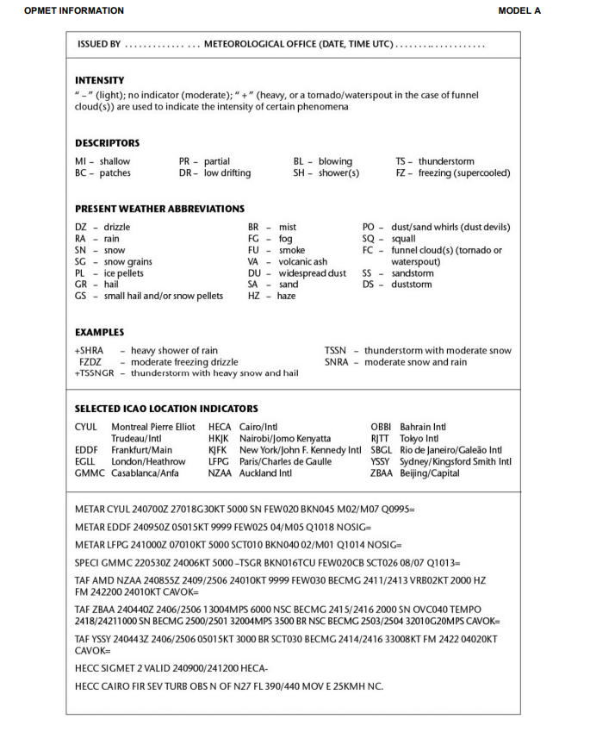

APP 1-3
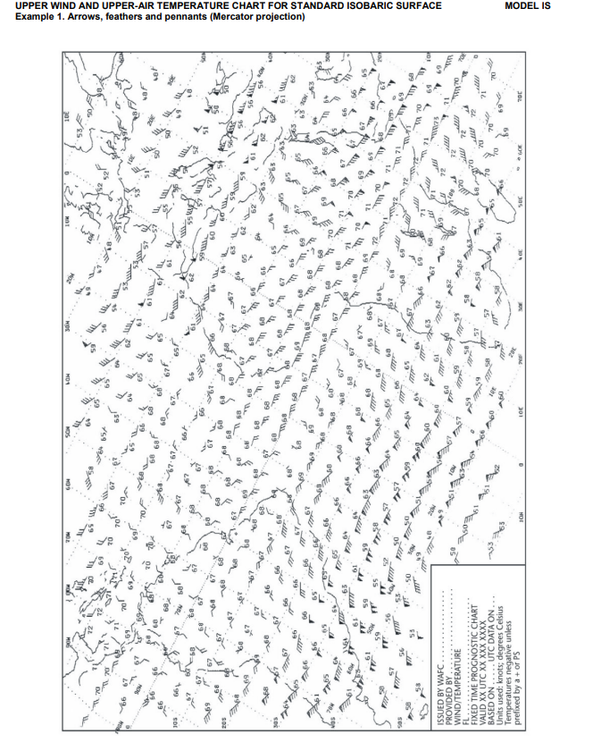

APP 1-4
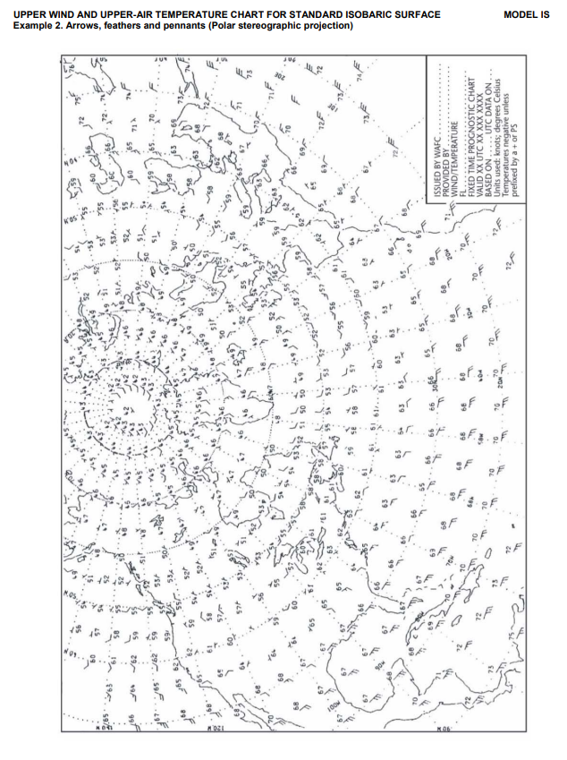

APP 1-5
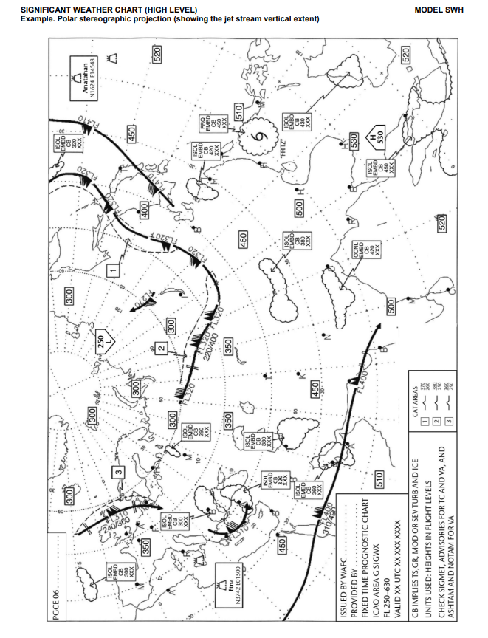

APP 1-6
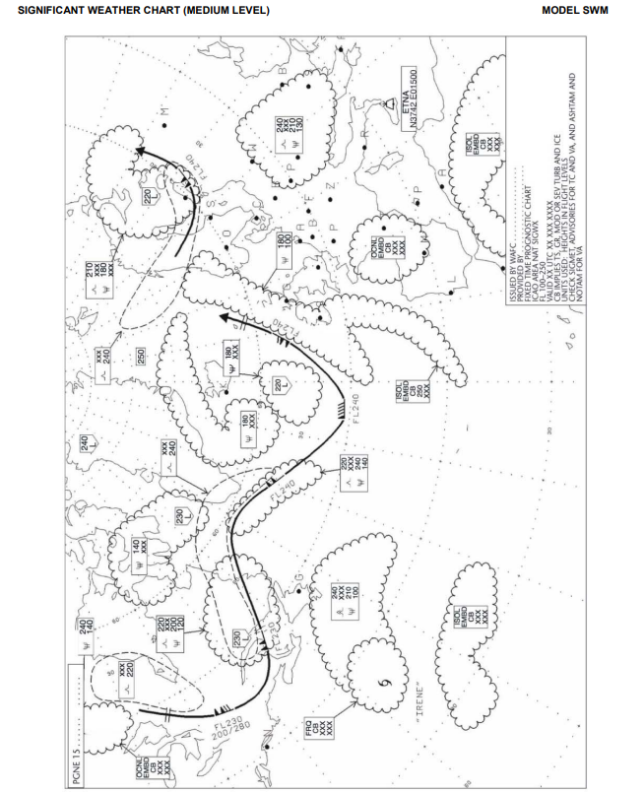

APP 1-7
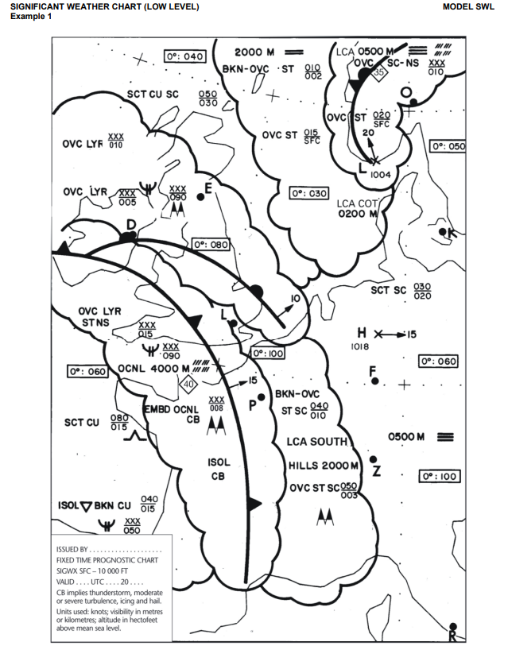

APP 1-8
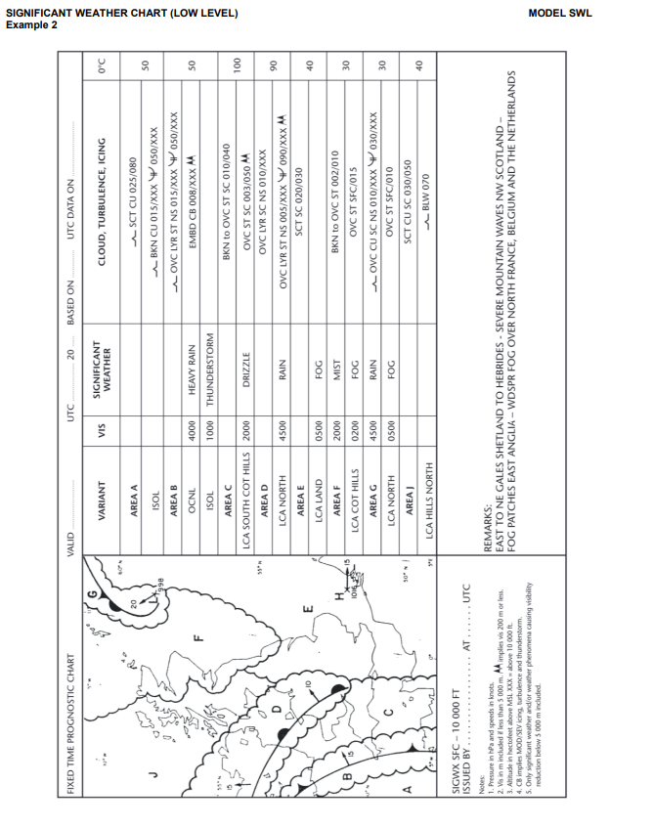

APP 1-9
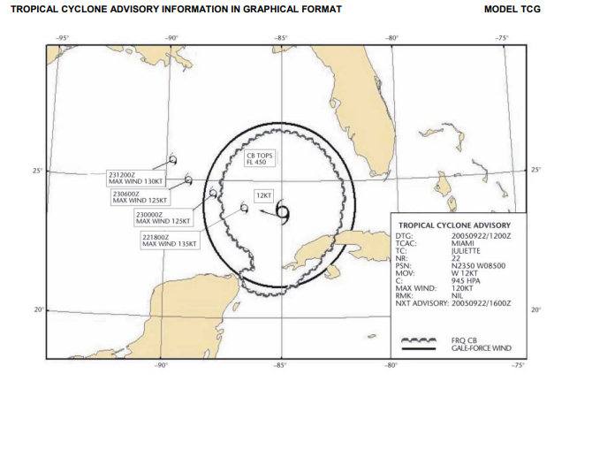

APP 1-10
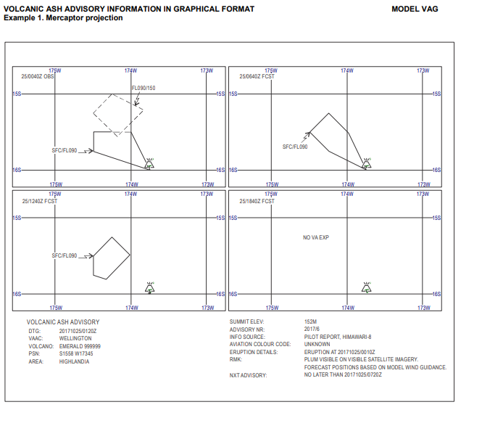

APP 1-11
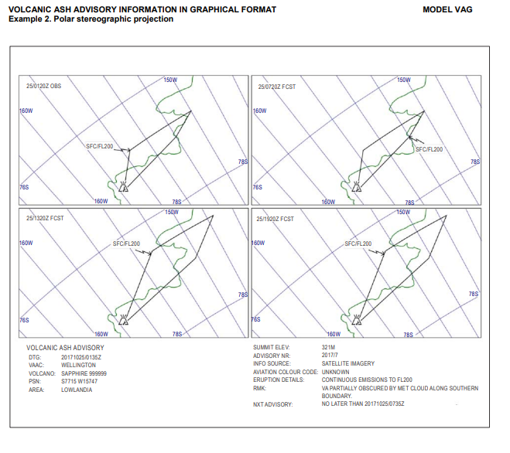

APP 1-12
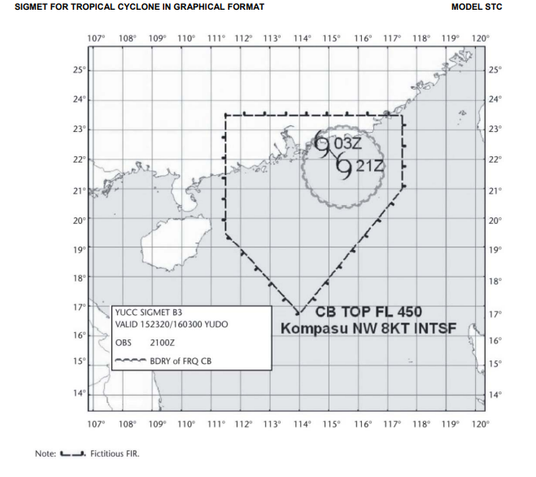

APP 1-13
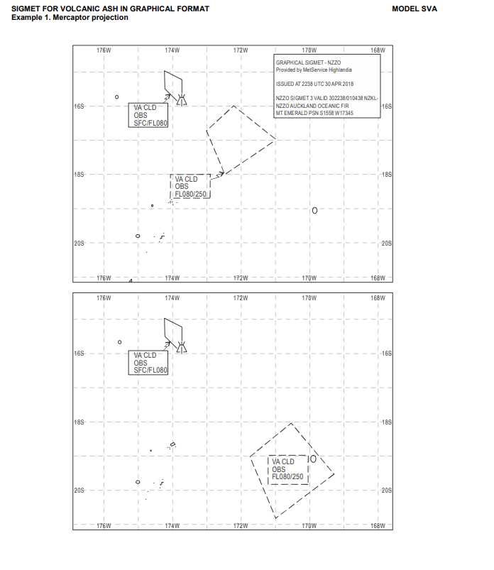

APP 1-14
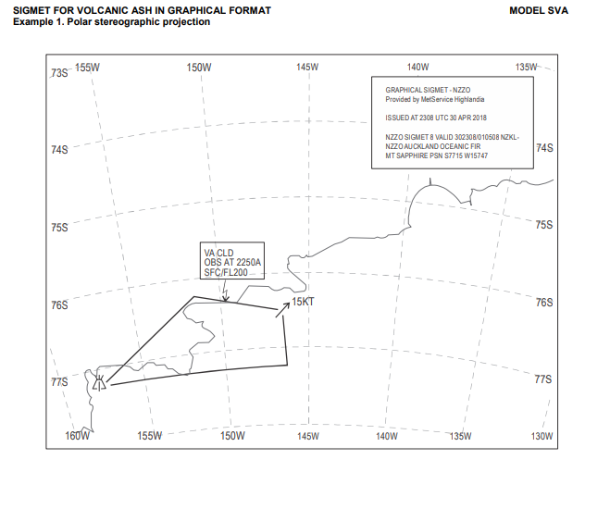

APP 1-15
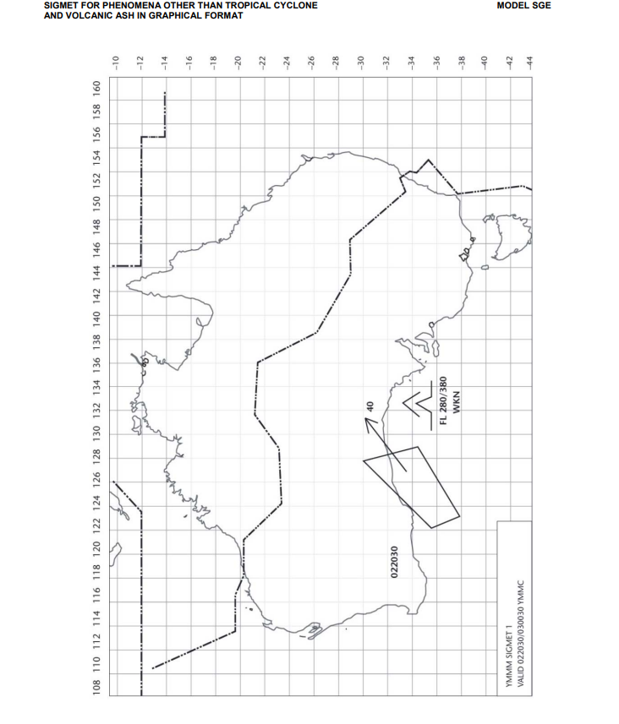

APP 1-16
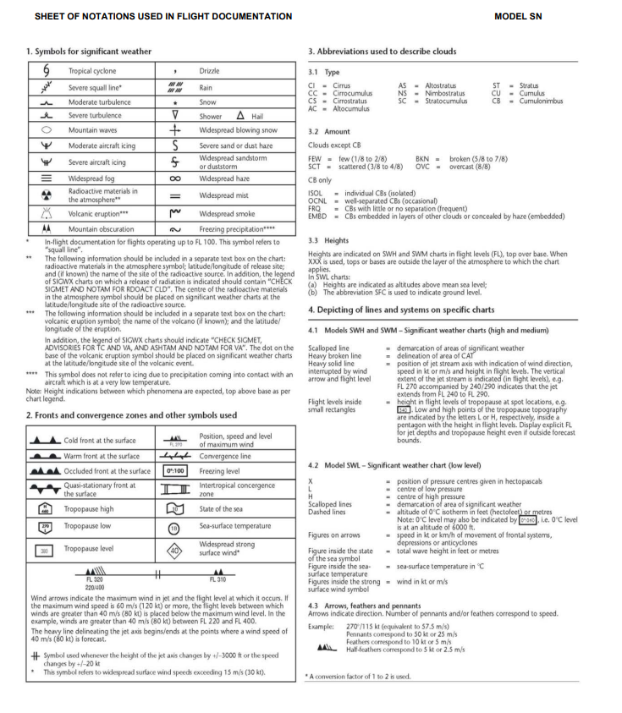

APPENDIX 2.

TECHNICAL SPECIFICATIONS RELATED TO GLOBAL SYSTEMS, SUPPORTING CENTRES AND METEOROLOGICAL OFFICES

World Area Forecast System
- Formats and codes
- World area forecast centres (WAFCs) shall adopt uniform formats and codes for the supply of forecasts.
- Upper-air gridded forecasts
- The forecasts of upper winds; upper-air temperature; and humidity; direction, speed and flight level of maximum wind; flight level and temperature of tropopause, areas of cumulonimbus clouds, icing, turbulence, and geopotential altitude of flight levels shall be prepared four times a day by a WAFC and shall be valid for fixed valid times at 6, 9, 12, 15, 18, 21, 24, 27, 30, 33 and 36 hours after the time (0000, 0600, 1200 and 1800 UTC) of the synoptic data on which the forecasts were based. Each forecast shall be disseminated as soon as technically feasible but not later than 5 hours after standard time of observation.
- The grid point forecasts prepared by a WAFC shall comprise:
- wind and temperature data for flight levels 50 (850 hPa), 80 (750 hPa), 100 (700 hPa), 140 (600 hPa), 180 (500 hPa), 210 (450 hPa), 240 (400 hPa), 270 (350 hPa), 300 (300 hPa), 320 (275 hPa), 340 (250 hPa), 360 (225 hPa), 390 (200 Pa), 410 (175 hPa), 450 (150 hPa), 480 (125 hPa) and 530 (100 hPa);
- flight level and temperature of tropopause;
- direction, speed and flight level of maximum wind;
- humidity data for flight levels 50 (850 hPa), 80 (750 hPa), 100 (700 hPa), 140 (600 hPa) and 180 (500 hPa);
- horizontal extent and flight levels of base and top of cumulonimbus clouds;
- icing for layers centred at flight levels 60 (800 hPa), 100 (700 hPa), 140 (600 hPa), 180 (500 hPa), 240 (400 hPa) and 300 (300 hPa);
- turbulence for layers centred at flight levels 100 (700 hPa), 140 (600 hPa), 180 (500 hPa), 240 (400 hPa), 270 (350 hPa), 300 (300 hPa), 340 (250 hPa), 390 (200 hPa) and 450 (150 hPa); and
- geopotential altitude data for flight levels 50 (850 hPa), 80 (750 hPa), 100 (700 hPa), 140 (600 hPa), 180 (500 hPa), 210 (450 hPa), 240 (400 hPa), 270 (350 hPa), 300 (300 hPa), 320 (275 hPa), 340 (250 hPa), 360 (225 hPa), 390 (200 hPa), 410 (175 hPa), 450 (150 hPa), 480 (125 hPa) and 530 (100 hPa).
- The foregoing grid point forecasts shall be issued by a WAFC in binary code form using the GRIB code form prescribed by the World Meteorological Organization (WMO).
- The foregoing grid point forecasts i), ii), iii), iv) and viii) shall be prepared by a WAFC in a regular grid with a horizontal resolution of 1.25° of latitude and longitude.
- The foregoing grid point forecasts v), vi) and vii) shall be prepared by a WAFC in a regular grid with a horizontal resolution of 0.25° of latitude and longitude.
- Significant weather (SIGWX) forecasts
- General provisions
- Forecasts of significant en-route weather phenomena shall be prepared as SIGWX forecasts four times a day by a WAFC and shall be valid for fixed valid times at 24 hours after the time (0000, 0600, 1200 and 1800 UTC) of the synoptic data on which the forecasts were based. Each forecast shall be disseminated as soon as technically feasible but not later than 7 hours after standard time of observation under normal operations and not later than 9 hours after standard time of observation during backup operations.
- SIGWX forecasts shall be issued in binary code form using the BUFR code form prescribed by WMO.
- Types of SIGWX forecasts
- SIGWX forecasts shall be issued as high-level SIGWX forecasts for flight levels between 250 and 630.
- Items included in SIGWX forecasts
- SIGWX forecasts shall include the following items:
- tropical cyclone provided that the maximum of the 10-minute mean surface wind speed is expected to reach or exceed 17 m/s (34 kt);
- severe squall lines;
- moderate or severe turbulence (in cloud or clear-air);
- moderate or severe icing;
- widespread sandstorm/duststorm;
- cumulonimbus clouds associated with thunderstorms and with i) to vi);
- flight level of tropopause;
- jet streams;
- information on the location of volcanic eruptions that are producing ash clouds of significance to aircraft operations, comprising: volcanic eruption symbol at the location of the volcano and, in a separate text box on the chart, the volcanic eruption symbol, the name of the volcano (if known) and the latitude/longitude of the eruption. In addition, the legend of SIGWX charts should indicate “CHECK SIGMET, ADVISORIES FOR TC AND VA, AND ASHTAM AND NOTAM FOR VA”; and
- information on the location of a release of radioactive materials into the atmosphere of significance to aircraft operations, comprising: the radioactive materials in the atmosphere symbol at the location of the release and, in a separate text box on the chart, the radioactive materials in the atmosphere symbol, latitude/longitude of the site of the release, and (if known) the name of site of the radioactive source. In addition, the legend of SIGWX charts on which a release of radiation is indicated should contain “CHECK SIGMET AND NOTAM FOR RDOACT CLD”.
- Criteria for including items in SIGWX forecasts
- The following criteria shall be applied for SIGWX forecasts:
- items i) to vi) in (3) shall only be included if expected to occur between the lower and upper levels of the SIGWX forecast;
- the abbreviation “CB” shall only be included when it refers to the occurrence or expected occurrence of cumulonimbus clouds:
- affecting an area with a maximum spatial coverage of 50 per cent or more of the area concerned;
- along a line with little or no space between individual clouds; or
- embedded in cloud layers or concealed by haze;
- the inclusion of “CB” shall be understood to include all weather phenomena normally associated with cumulonimbus clouds, i.e. thunderstorm, moderate or severe icing, moderate or severe turbulence and hail;
- where a volcanic eruption or a release of radioactive materials into the atmosphere warrants the inclusion of the volcanic eruption symbol or the radioactive materials in the atmosphere symbol in SIGWX forecasts, the symbols shall be included on SIGWX forecasts irrespective of the height to which the ash column or radioactive material is reported or expected to reach; and
- in the case of co-incident or the partial overlapping of items i), ix) and x) in (3), the highest priority shall be given to item ix), followed by items x) and i). The item with the highest priority shall be placed at the location of the event, and an arrow shall be used to link the location of the other item(s) to its associated symbol or text box.

Aerodrome Meteorological Offices
- Use of world area forecast system (WAFS) products
- Aerodrome meteorological offices shall use WAFS forecasts issued by the WAFCs in the preparation of flight documentation, whenever these forecasts cover the intended flight path in respect of time, altitude and geographical extent, unless otherwise agreed between the meteorological authority and the operator concerned.
- In order to ensure uniformity and standardization of flight documentation, the WAFS GRIB and BUFR data received and, as of 4 November 2021, IWXXM data received, shall be decoded into standard WAFS charts in accordance with relevant provisions in this Annex, and the meteorological content and identification of the originator of the WAFS forecasts shall not be amended.
- Notification of WAFC concerning significant discrepancies
Aerodrome meteorological offices using WAFS BUFR or, as of 4 November 2021, IWXXM data shall notify the WAFC concerned immediately if significant discrepancies are detected or reported in respect of WAFS SIGWX forecasts concerning:
- icing, turbulence, cumulonimbus clouds that are obscured, frequent, embedded or occurring at a squall line, and sandstorms/duststorms; and
- volcanic eruptions or a release of radioactive materials into the atmosphere, of significance to aircraft operations. The WAFC receiving the message shall acknowledge its receipt to the originator, together with a brief comment on the report and any action taken, using the same means of communication employed by the originator.

Volcanic Ash Advisory Centres
- Volcanic ash advisory information
- The advisory information on volcanic ash issued in abbreviated plain language, using approved ICAO abbreviations and numerical values of self-explanatory nature, shall be in accordance with the template shown in Table A2-1. When no approved ICAO abbreviations are available, English plain language text, to be kept to a minimum, shall be used.
- As of 5 November 2020, volcanic ash advisory information shall be disseminated in IWXXM GML form in addition to the dissemination of this advisory information in accordance with (1).
- The volcanic ash advisory information listed in Table A2-1, when prepared in graphical format, shall be as specified in Appendix 1 and issued using the portable network graphics (PNG) format.

Tropical Cyclone Advisory Centres
- Tropical cyclone advisory information
- The advisory information on tropical cyclones shall be issued for tropical cyclones when the maximum of the 10-minute mean surface wind speed is expected to reach or exceed 17 m/s (34 kt) during the period covered by the advisory.
- The advisory information on tropical cyclones disseminated in abbreviated plain language, using approved ICAO abbreviations and numerical values of self-explanatory nature.
- As of 5 November 2020, tropical cyclone advisory centres shall disseminate tropical cyclone advisory information in IWXXM GML form in addition to the dissemination of this advisory information in abbreviated plain language in accordance with (2).
- The tropical cyclone advisory information listed in Table A2-2, when prepared in graphical format, shall be as specified in Appendix 1 and issued using the PNG format.

Space Weather Centres
- Space weather advisory information
- As of 5 November 2020, space weather advisory information shall be disseminated in IWXXM GML form, in addition to the dissemination of this advisory information in abbreviated plain language.

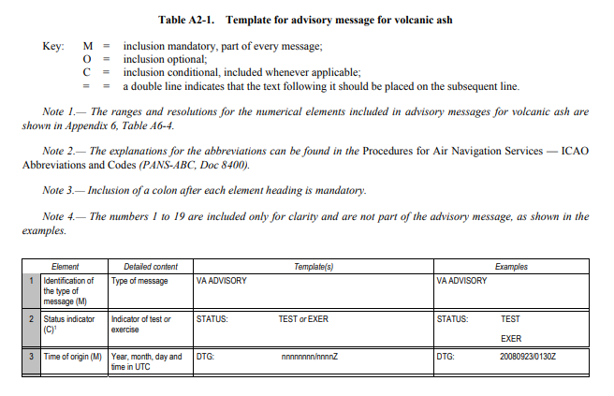
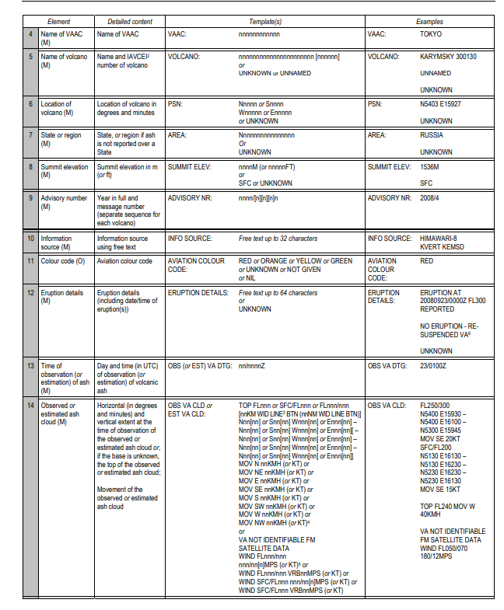
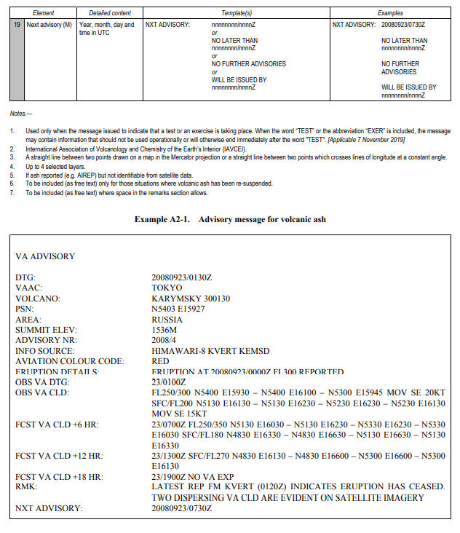
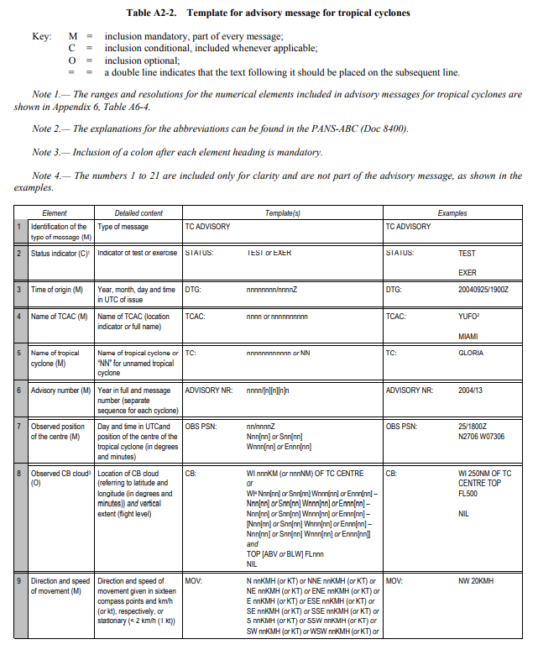
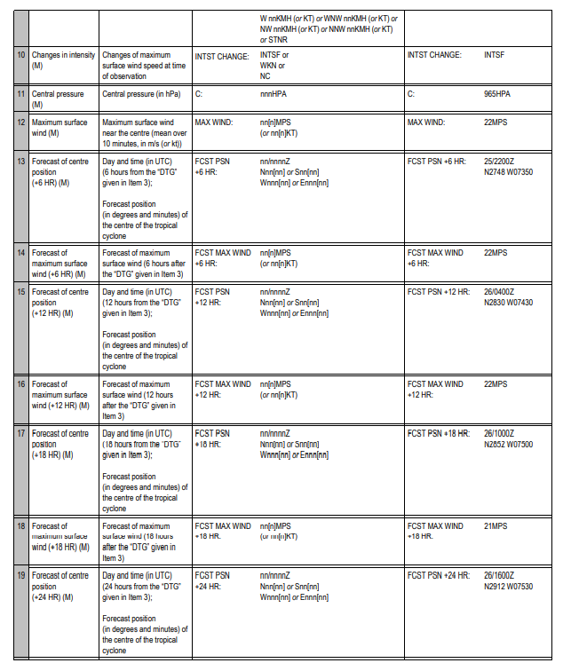
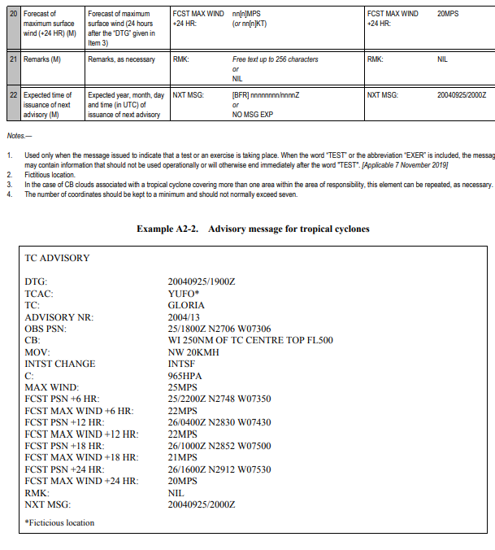
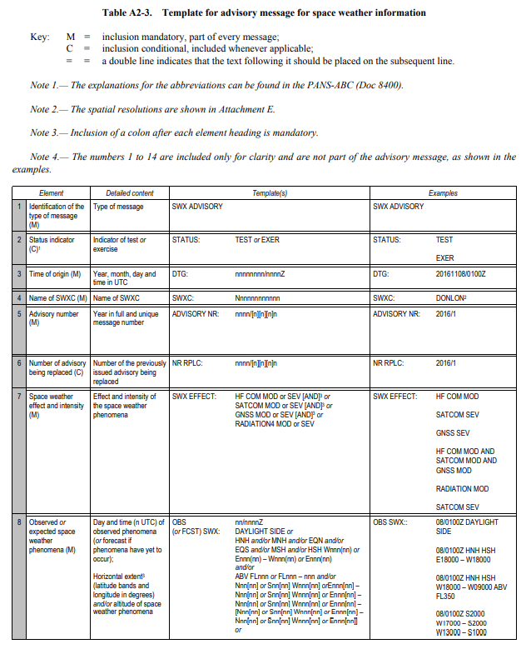
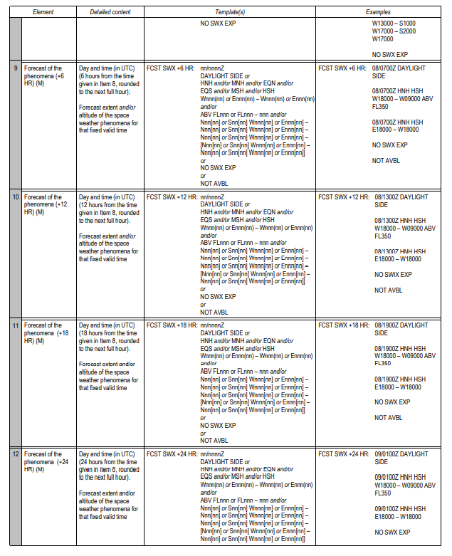
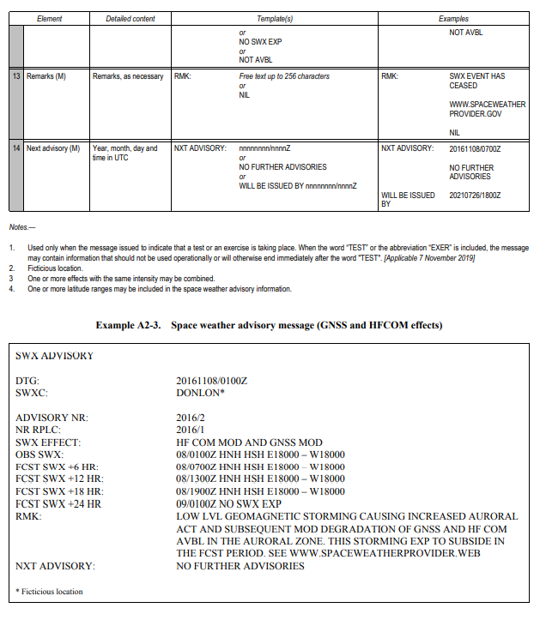
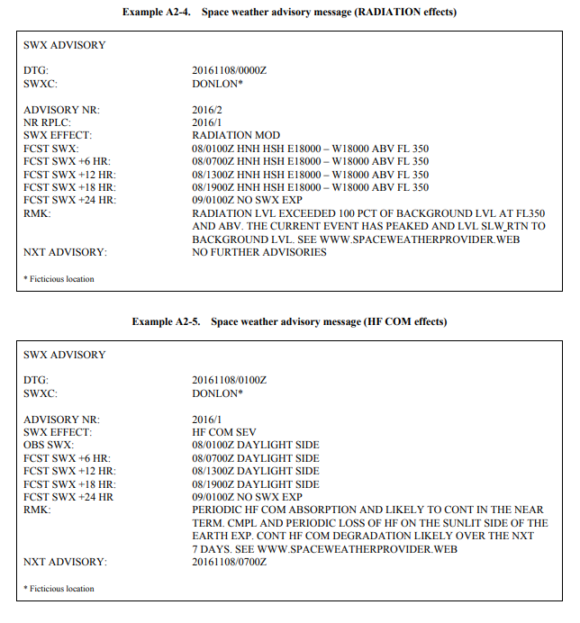

APPENDIX 3.

TECHNICAL SPECIFICATIONS RELATED TO METEOROLOGICAL OBSERVATIONS AND REPORTS

General criteria related to meteorological reports
- Format of meteorological reports
- Local routine and special reports shall be issued in abbreviated plain language, in accordance with the template shown in Table A3-1.
- METAR and SPECI shall be issued in accordance with the template shown in Table A3-2 and disseminated in the METAR and SPECI code forms prescribed by WMO.
- As of 5 November 2020, METAR and SPECI shall be disseminated in IWXXM GML form in addition to the dissemination of the METAR and SPECI in accordance with (2).
- Use of CAVOK
When the following conditions occur simultaneously at the time of observation:
- visibility, 10 km or more, and the lowest visibility is not reported;
- no cloud of operational significance;
- no weather of significance to aviation as given in, MET.057 d) 1) (iii); information on visibility, runway visual range, present weather and cloud amount, cloud type and height of cloud base shall be replaced in all meteorological reports by the term “CAVOK”.
- Criteria for issuance of local special reports and SPECI
- The list of criteria for the issuance of local special reports shall include the following:
- those values which most closely correspond with the operating minima of the operators using the aerodrome;
- those values which satisfy other local requirements of the air traffic services units and of the operators;
- an increase in air temperature of 2°C or more from that given in the latest report, or an alternative threshold value as agreed between the meteorological authority, the appropriate ATS authority and the operators concerned;
- the available supplementary information concerning the occurrence of significant meteorological conditions in the approach and climb-out areas as given in Table A3-1;
- when noise abatement procedures are applied in accordance with the PANS-ATM (Doc 4444) and the variation from the mean surface wind speed (gusts) has changed by 2.5 m/s (5 kt) or more from that at the time of the latest report, the mean speed before and/or after the change being 7.5 m/s (15 kt) or more; and
- those values which constitute criteria for SPECI.
- Where required in accordance with Chapter 4, MET.012 b) 2), SPECI shall be issued whenever changes in accordance with the following criteria occur:
- when the mean surface wind direction has changed by 60° or more from that given in the latest report, the mean speed before and/or after the change being 5 m/s (10 kt) or more;
- when the mean surface wind speed has changed by 5 m/s (10 kt) or more from that given in the latest report;
- when the variation from the mean surface wind speed (gusts) has changed by 5 m/s (10 kt) or more from that at the time of the latest report, the mean speed before and/or after the change being 7.5 m/s (15 kt) or more;
- when the onset, cessation or change in intensity of any of the following weather phenomena occurs:
- freezing precipitation
- moderate or heavy precipitation (including showers thereof)
- thunderstorm (with precipitation);
- when the onset or cessation of any of the following weather phenomena occurs:
- freezing fog
- thunderstorm (without precipitation);
- when the amount of a cloud layer below 450 m (1 500 ft) changes:
- from SCT or less to BKN or OVC; or
- from BKN or OVC to SCT or less.
- When a deterioration of one weather element is accompanied by an improvement in another element, a single SPECI shall be issued; it shall then be treated as a deterioration report.

Dissemination of meteorological reports
- METAR and SPECI
- METAR and SPECI shall be disseminated to international OPMET databanks and the centres designated by regional air navigation agreement for the operation of aeronautical fixed service Internet-based services, in accordance with regional air navigation agreement.
- METAR and SPECI shall be disseminated to other aerodromes in accordance with regional air navigation agreement.
- SPECI representing a deterioration in conditions shall be disseminated immediately after the observation. A SPECI representing a deterioration of one weather element and an improvement in another element shall be disseminated
immediately after the observation.
- Local routine and special reports
- Local routine reports shall be transmitted to local air traffic services units and shall be made available to the operators and to other users at the aerodrome.
- Local special reports shall be transmitted to local air traffic services units as soon as the specified conditions occur. However, as agreed between the meteorological authority and the appropriate ATS authority, they need not be issued in respect of:
- any element for which there is in the local air traffic services unit a display corresponding to the one in the meteorological station, and where arrangements are in force for the use of this display to update information included in local routine and special reports; and
- runway visual range, when all changes of one or more steps on the reporting scale in use are being reported to the local air traffic services unit by an observer on the aerodrome.
Local special reports shall also be made available to the operators and to other users at the aerodrome.

Observing and reporting of meteorological elements
- Surface wind
- Displays
- Surface wind displays relating to each sensor shall be located in the meteorological station with corresponding displays in the appropriate air traffic services units. The displays in the meteorological station and in the air traffic services units shall relate to the same sensors, and where separate sensors are required, the displays shall be clearly marked to identify the runway and section of runway monitored by each sensor.
- Averaging
- The averaging period for surface wind observations shall be:
- 2 minutes for local routine and special reports and for wind displays in air traffic services units; and
- 10 minutes for METAR and SPECI, except that when the 10-minute period includes a marked discontinuity in the wind direction and/or speed, only data occurring after the discontinuity shall be used for obtaining mean values; hence, the time interval in these circumstances shall be correspondingly reduced.
- Reporting
- In local routine reports, local special reports, METAR and SPECI, the surface wind direction and speed shall be reported in steps of 10 degrees true and 1 metre per second (or 1 knot), respectively. Any observed value which does not fit the reporting scale in use shall be rounded to the nearest step in the scale.
- In local routine reports, local special reports, METAR and SPECI:
- the units of measurement used for the wind speed shall be indicated;
- variations from the mean wind direction during the past 10 minutes shall be reported as follows, if the total variation is 60° or more:
- when the total variation is 60° or more and less than 180° and the wind speed is 1.5 m/s (3 kt) or more, such directional variations shall be reported as the two extreme directions between which the surface wind has varied;
- when the total variation is 60° or more and less than 180° and the wind speed is less than 1.5 m/s (3 kt), the wind direction shall be reported as variable with no mean wind direction; or
- when the total variation is 180° or more, the wind direction shall be reported as variable with no mean wind direction;
- variations from the mean wind speed (gusts) during the past 10 minutes shall be reported when the maximum wind speed exceeds the mean speed by:
- 2.5 m/s (5 kt) or more in local routine and special reports when noise abatement procedures are applied in accordance with the PANS-ATM (Doc 4444); or
- 5 m/s (10 kt) or more otherwise;
- when a wind speed of less than 0.5 m/s (1 kt) is reported, it shall be indicated as calm;
- when a wind speed of 50 m/s (100 kt) or more is reported, it shall be indicated to be more than 49 m/s (99 kt); and
- when the 10-minute period includes a marked discontinuity in the wind direction and/or speed, only variations from the mean wind direction and mean wind speed occurring since the discontinuity shall be reported.
- In local routine and special reports:
- if the surface wind is observed from more than one location along the runway, the locations for which these values
- are representative shall be indicated;
- when there is more than one runway in use and the surface wind related to these runways is observed, the available
- wind values for each runway shall be given, and the runways to which the values refer shall be reported;
- when variations from the mean wind direction are reported in accordance with (3) ii) b) 2), the two extreme directions between which the surface wind has varied shall be reported; and
- when variations from the mean wind speed (gusts) are reported in accordance with (3) ii) c), they shall be reported as the maximum and minimum values of the wind speed attained.
- In METAR and SPECI, when variations from the mean wind speed (gusts) are reported in accordance with (3) ii) c), the maximum value of the wind speed attained shall be reported.
- Visibility
- Reporting
- In local routine reports, local special reports, METAR and SPECI, the visibility shall be reported in steps of 50 m when it is less than 800 m; in steps of 100 m when it is 800 m or more but less than 5 km; in kilometre steps when it is 5 km or more but less than 10 km; and as 10 km when it is 10 km or more except when the conditions for the use of CAVOK apply. Any observed value which does not fit the reporting scale in use shall be rounded down to the nearest lower step in the scale.
- In local routine and special reports, visibility along the runway(s) shall be reported together with the units of measurement used to indicate visibility.
- Runway visual range
- Instrumented systems
- Instrumented systems based on transmissometers or forward-scatter meters shall be used to assess runway visual range on runways intended for Category II and III instrument approach and landing operations.
- Display
- Where runway visual range is determined by instrumented systems, one display or more, if required, shall be located in the meteorological station with corresponding displays in the appropriate air traffic services units. The displays in the meteorological station and in the air traffic services units shall be related to the same sensors, and where separate sensors are required, the displays shall be clearly marked to identify the runway and section of runway monitored by each sensor.
- Averaging
- Where instrumented systems are used for the assessment of runway visual range, their output shall be updated at least every 60 seconds to permit the provision of current, representative values. The averaging period for runway visual range values shall be:
- 1 minute for local routine and special reports and for runway visual range displays in air traffic services units; and
- 10 minutes for METAR and SPECI, except that when the 10-minute period immediately preceding the observation includes a marked discontinuity in runway visual range values, only those values occurring after the discontinuity shall be used for obtaining mean values.
- Reporting
- In local routine reports, local special reports, METAR and SPECI, the runway visual range shall be reported in steps of 25 m when it is less than 400 m; in steps of 50 m when it is between 400 m and 800 m; and in steps of 100 m when it is more than 800 m. Any observed value which does not fit the reporting scale in use shall be rounded down to the nearest lower step in the scale.
- In local routine reports, local special reports, METAR and SPECI:
- when runway visual range is above the maximum value that can be determined by the system in use, it shall be reported using the abbreviation “ABV” in local routine and special reports and the abbreviation “P” in METAR and SPECI, followed by the maximum value that can be determined by the system; and
- when the runway visual range is below the minimum value that can be determined by the system in use, it shall be reported using the abbreviation “BLW” in local routine and special reports and the abbreviation “M” in METAR and SPECI, followed by the minimum value that can be determined by the system
- In local routine and special reports:
- the units of measurement used shall be included;
- if runway visual range is observed from only one location along the runway, i.e. the touchdown zone, it shall be included without any indication of location;
- if the runway visual range is observed from more than one location along the runway, the value representative of the touchdown zone shall be reported first, followed by the values representative of the mid-point and stop-end and the locations for which these values are representative shall be indicated; and
- when there is more than one runway in use, the available runway visual range values for each runway shall be reported and the runways to which the values refer shall be indicated.
- Present weather
- Reporting
- In local routine and special reports, observed present weather phenomena shall be reported in terms of type and characteristics and qualified with respect to intensity, as appropriate.
- In METAR and SPECI, observed present weather phenomena shall be reported in terms of type and characteristics and qualified with respect to intensity or proximity to the aerodrome, as appropriate
- In local routine reports, local special reports, METAR and SPECI, the following characteristics of present weather phenomena, as necessary, shall be reported, using their respective abbreviations and relevant criteria, as appropriate.
- In local routine reports, local special reports, METAR and SPECI:
- one or more, up to a maximum of three, of the present weather abbreviations shall be used, as necessary, together with an indication, where appropriate, of the characteristics given in iii) and intensity or proximity to the aerodrome, so as to convey a complete description of the present weather of significance to flight operations;
- the indication of intensity or proximity, as appropriate, shall be reported first followed respectively by the characteristics and the type of weather phenomena; and
- where two different types of weather are observed, they shall be reported in two separate groups, where the intensity or proximity indicator refers to the weather phenomenon which follows the indicator. However, different types of precipitation occurring at the time of observation shall be reported as one single group with the dominant type of precipitation reported first and preceded by only one intensity qualifier which refers to the intensity of the total precipitation.
- Clouds
- Reference level
- The height of cloud base shall be reported above aerodrome elevation. When a precision approach runway is in use which has a threshold elevation 15 m (50 ft) or more below the aerodrome elevation, local arrangements shall be made in order that the height of cloud bases reported to arriving aircraft shall refer to the threshold elevation. In the case of reports from offshore structures, the height of cloud base shall be given above mean sea level.
- Reporting
- In local routine reports, local special reports, METAR and SPECI, the height of cloud base shall be reported in steps of 30 m (100 ft) up to 3 000 m (10 000 ft).
- Any observed value in i), which does not fit the reporting scale in use shall be rounded down to the nearest lower step in the scale.
- In local routine and special reports:
- the units of measurement used for the height of cloud base and vertical visibility shall be indicated; and
- when there is more than one runway in use and the heights of cloud bases are observed by instruments for these runways, the available heights of cloud bases for each runway shall be reported and the runways to which the values refer shall be indicated.
- Air temperature and dew-point temperature
- Reporting
- In local routine reports, local special reports, METAR and SPECI, the air temperature and the dew-point temperature shall be reported in steps of whole degrees Celsius. Any observed value which does not fit the reporting scale in use shall be rounded to the nearest whole degree Celsius, with observed values involving 0.5° rounded up to the next higher whole degree Celsius.
- In local routine reports, local special reports, METAR and SPECI, a temperature below 0°C shall be identified.
- Atmospheric pressure
- Display
- When automated equipment is used for the measurement of atmospheric pressure, QNH and, if required in accordance with (2) (ii) (B), QFE displays relating to the barometer shall be located in the meteorological station with corresponding displays in the appropriate air traffic services units. When QFE values are displayed for more than one runway, as specified in (2) (ii) (D), the displays shall be clearly marked to identify the runway to which the QFE value displayed refers.
- Reporting
- For local routine reports, local special reports, METAR and SPECI, QNH and QFE shall be computed in tenths of hectopascals and reported therein in steps of whole hectopascals, using four digits. Any observed value which does not fit the reporting scale in use shall be rounded down to the nearest lower whole hectopascal.
- In local routine and special reports:
- QNH shall be included;
- QFE shall be included if required by users or as agreed between the meteorological authority, the appropriate ATS authority and the operators concerned, on a regular basis;
- the units of measurement used for QNH and QFE values shall be included; and
- if QFE values are required for more than one runway, the required QFE values for each runway shall be reported and the runways to which the values refer shall be indicated.
- In METAR and SPECI, only QNH values shall be included.
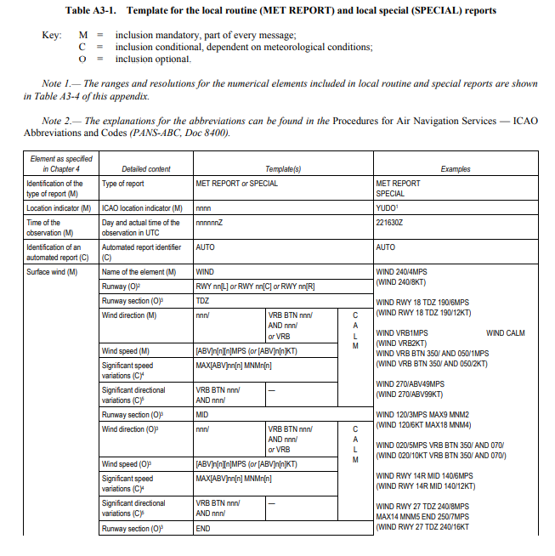
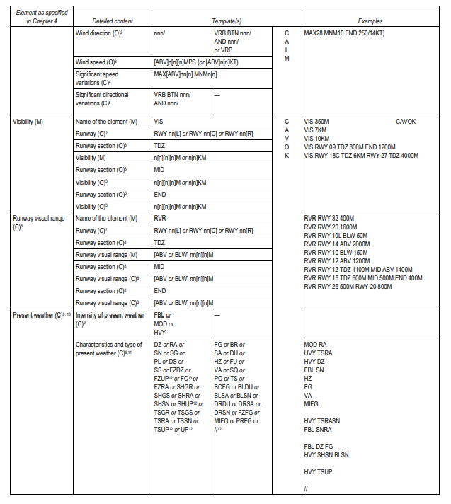
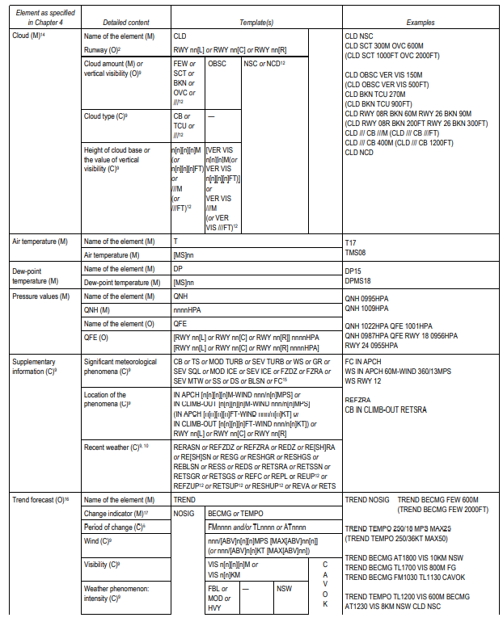
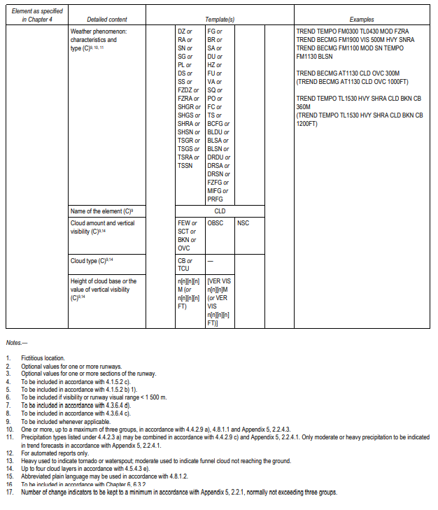
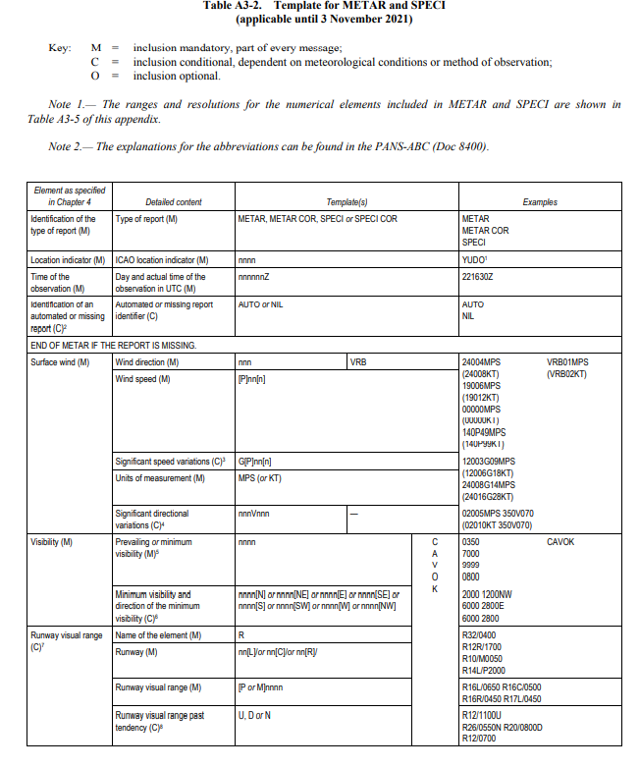
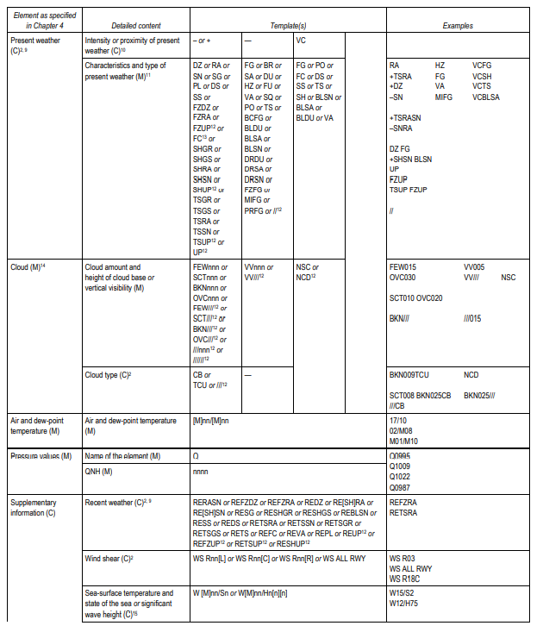
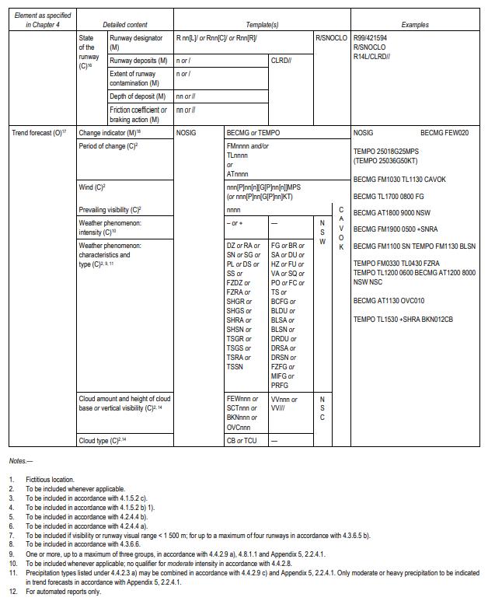
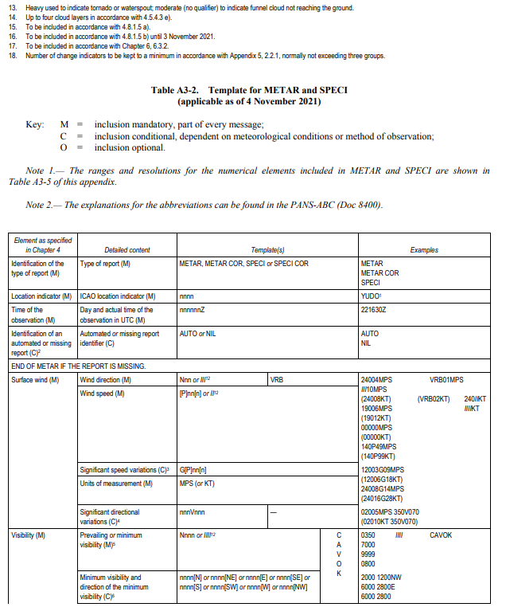
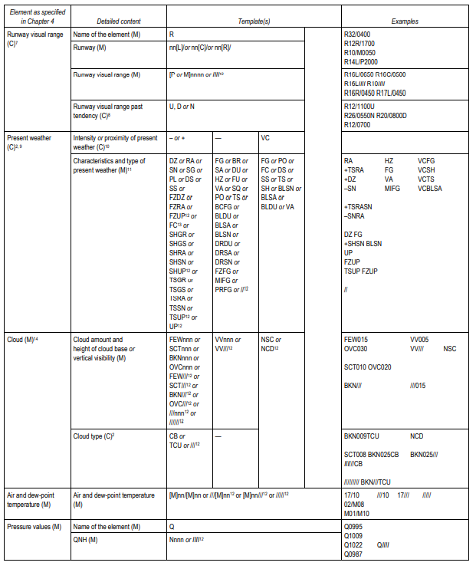
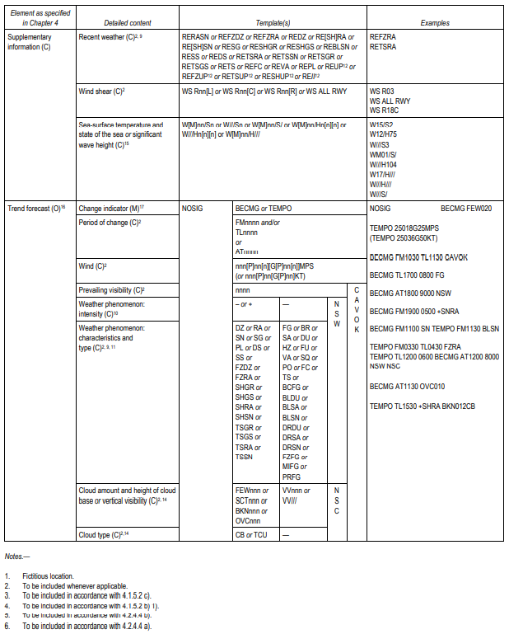
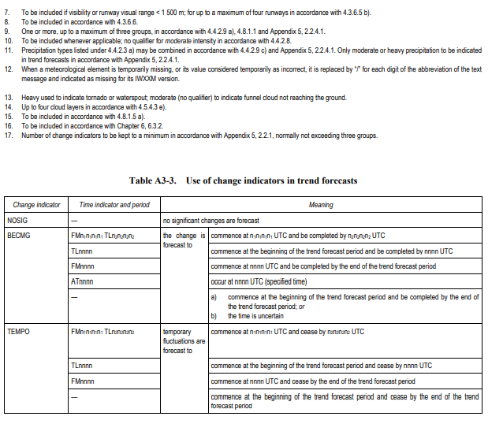
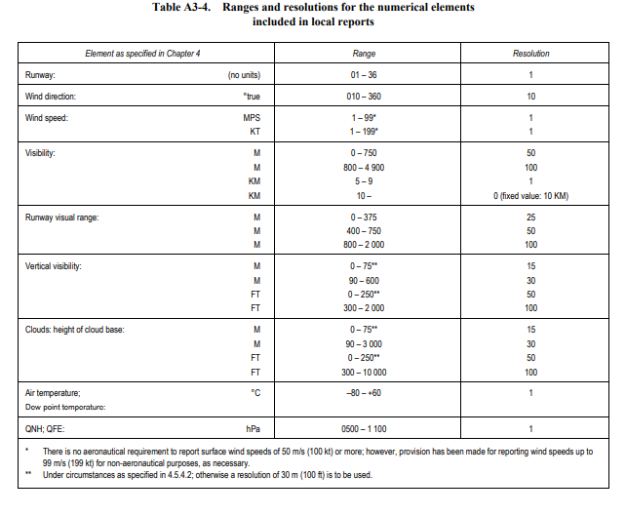
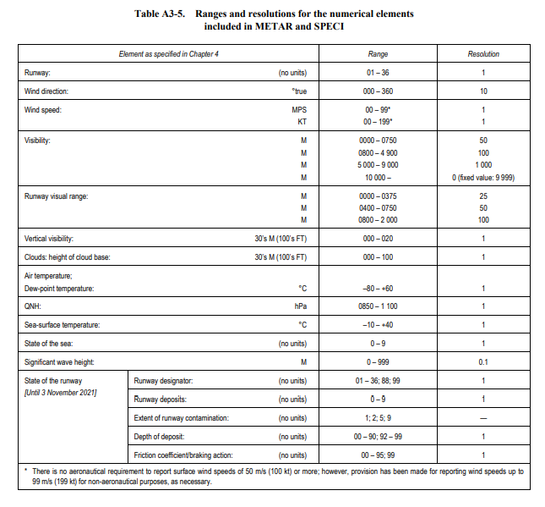
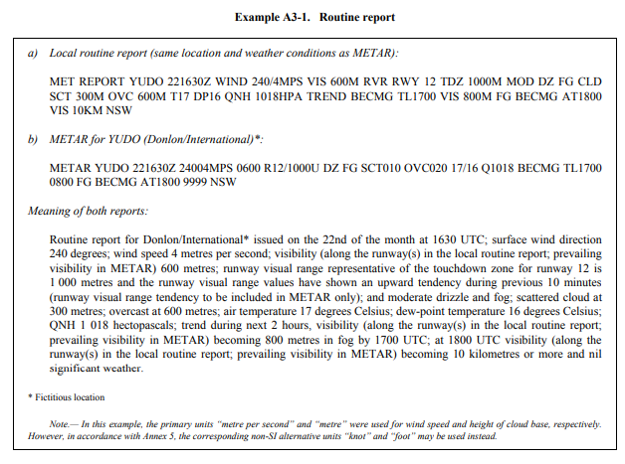
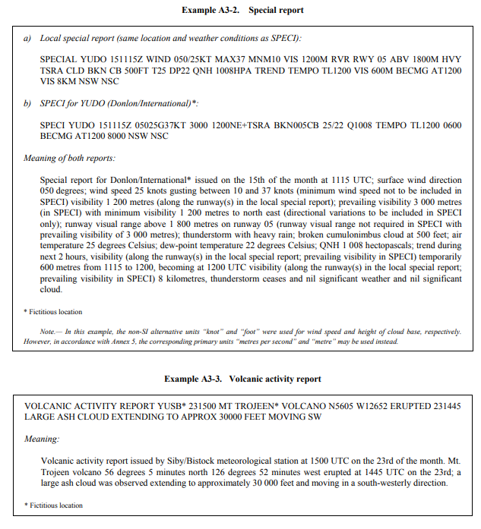

APPENDIX 4.

TECHNICAL SPECIFICATIONS RELATED TO AIRCRAFT OBSERVATIONS AND REPORTS

Contents of Air-Reports
- Routine air-reports by air-ground data link
- When air-ground data link is used and automatic dependent surveillance — contract (ADS-C) or SSR Mode S is being applied, the elements contained in routine air-reports shall be:

Message type designator
Aircraft identification

Data block 1
Latitude
Longitude
Level
Time

Data block 2
Wind direction
Wind speed
Wind quality flag
Air temperature
Turbulence (if available)
Humidity (if available)

- When air-ground data link is used while ADS-C and SSR Mode S are not being applied, the elements contained in routine reports shall be:

Message type designator

Section 1 (Position information)
Aircraft identification
Position or latitude and longitude
Time
Flight level or altitude
Next position and time over
Ensuing significant point

Section 2 (Operational information)
Estimated time of arrival
Endurance

Section 3 (Meteorological information)
Air temperature
Wind direction
Wind speed
Turbulence
Aircraft icing
Humidity (if available)

- Special air-reports by air-ground data link
When air-ground data link is used, the elements contained in special air-reports shall be:

Message type designator
Aircraft identification

Data block 1
Latitude
Longitude
Level
Time

Data block 2
Wind direction
Wind speed
Wind quality flag
Air temperature
Turbulence (if available)
Humidity (if available)

Data block 3
Condition prompting the issuance of a special air-report (one condition to be selected from the list presented in Table A4-1).

- Special air-reports by voice communications
When voice communications are used, the elements contained in special air-reports shall be:

Message type designator
Section 1 (Position information)
Aircraft identification
Position or latitude and longitude
Time
Level or range of levels

Section 3 (Meteorological information)
Condition prompting the issuance of a special air-report, to be selected from the list presented in Table A4-1.

Criteria for Reporting
- General
When air-ground data link is used, the wind direction, wind speed, wind quality flag, air temperature, turbulence and humidity included in air-reports shall be reported in accordance with the following criteria.
- Wind direction
The wind direction shall be reported in terms of degrees true, rounded to the nearest whole degree.
- Wind speed
The wind speed shall be reported in metres per second or knots, rounded to the nearest 1 m/s (1 knot). The units of measurement used for the wind speed shall be indicated.
- Wind quality flag
The wind quality flag shall be reported as 0 when the roll angle is less than 5 degrees and as 1 when the roll angle is 5 degrees or more.
- Air temperature
The air temperature shall be reported to the nearest tenth of a degree Celsius.
- Turbulence
The turbulence shall be reported in terms of the cube root of the eddy dissipation rate (EDR).
- Routine air-reports
The turbulence shall be reported during the en-route phase of the flight and shall refer to the 15-minute period immediately preceding the observation. Both the average and peak value of turbulence, together with the time of occurrence of the peak value to the nearest minute, shall be observed. The average and peak values shall be reported in terms of EDR. The time of occurrence of the peak value shall be reported as indicated in Table A4-2. The turbulence shall be reported during the climb-out phase for the first 10 minutes of the flight and shall refer to the 30-second period immediately preceding the observation. The peak value of turbulence shall be observed.
- Interpretation of the turbulence report
Turbulence shall be considered:
- severe when the peak value of EDR equals or exceeds 0.45;
- moderate when the peak value of EDR is equal to or above 0.20 and below 0.45;
- light when the peak value of EDR is above 0.10 and below 0.20; and
- nil when the peak value of EDR is below or equal to 0.10.
- Special air-reports
Special air-reports on turbulence shall be made during any phase of the flight whenever the peak value of EDR equals or exceeds 0.20. The special air-report on turbulence shall be made with reference to the 1-minute period immediately preceding the observation. Both the average and peak value of turbulence shall be observed. The average and peak values shall be reported in terms of EDR. Special air-reports shall be issued every minute until such time as the peak values of EDR fall below 0.20.
- Humidity
The humidity shall be reported as the relative humidity, rounded to the nearest whole per cent.

Exchange of Air-Reports
- Responsibilities of the meteorological watch offices
- The meteorological watch office shall transmit without delay the special air-reports received by voice communications to the world area forecast centres (WAFCs) and the centres designated by regional air navigation agreement for the operation of aeronautical fixed service Internet-based services.
- The meteorological watch office shall transmit without delay special air-reports of pre-eruption volcanic activity, a volcanic eruption or volcanic ash cloud received to the associated volcanic ash advisory centres.
- When a special air-report is received at the meteorological watch office but the forecaster considers that the phenomenon causing the report is not expected to persist and, therefore, does not warrant issuance of a SIGMET, the special air-report shall be disseminated in the same way that SIGMET messages are disseminated in accordance with Appendix 6, MET.065, b), 1) i.e. to meteorological watch offices, WAFCs, and other meteorological offices in accordance with regional air navigation agreement.
- Responsibilities of world area forecast centres
Air-reports received at WAFCs shall be further disseminated as basic meteorological data.
- Format of air-reports
Air-reports shall be exchanged in the format in which they are received.

Specific provisions related to reporting Wind Shear and Volcanic Ash
- Post-flight reporting of volcanic activity
- On arrival of a flight at an aerodrome, the completed report of volcanic activity shall be delivered by the operator or a flight crew member, without delay, to the aerodrome meteorological office, or if such office is not easily accessible to arriving flight crew members, the completed form shall be dealt with in accordance with local arrangements made by the meteorological authority and the operator.
- The completed report of volcanic activity received by an aerodrome meteorological office shall be transmitted without delay to the meteorological watch office responsible for the provision of meteorological watch for the flight information region in which the volcanic activity was observed.

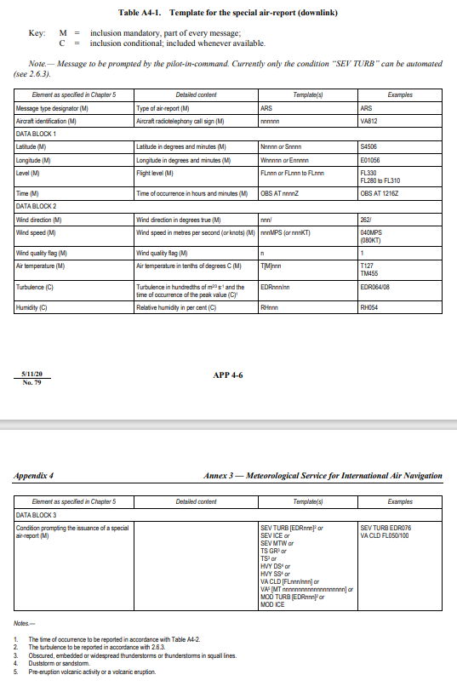
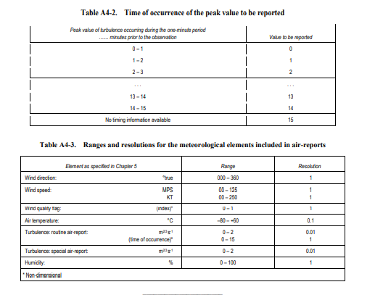

APPENDIX 5.

TECHNICAL SPECIFICATIONS RELATED TO FORECASTS

Criteria related to TAF
- TAF format
- TAF shall be issued in accordance with the template shown in Table A5-1 and disseminated in the TAF code form prescribed by the World Meteorological Organization (WMO).
- As of 5 November 2020, TAF shall be disseminated in IWXXM GML form in addition to the dissemination of the TAF in accordance with (1).
- Inclusion of meteorological elements in TAF
Surface wind In forecasting surface wind, the expected prevailing direction shall be given. When it is not possible to forecast a prevailing surface wind direction due to its expected variability, for example, during light wind conditions (less than 1.5 m/s (3 kt)) or thunderstorms, the forecast wind direction shall be indicated as variable using “VRB”. When the wind is forecast to be less than 0.5 m/s (1 kt), the forecast wind speed shall be indicated as calm. When the forecast maximum speed (gust) exceeds the forecast mean wind speed by 5 m/s (10 kt) or more, the forecast maximum wind speed shall be indicated. When a wind speed of 50 m/s (100 kt) or more is forecast, it shall be indicated to be more than 49 m/s (99 kt).
- Weather phenomena
One or more, up to a maximum of three, of the following weather phenomena or combinations thereof, together with their characteristics and, where appropriate, intensity, shall be forecast if they are expected to occur at the aerodrome:
— freezing precipitation
— freezing fog
— moderate or heavy precipitation (including showers thereof)
— low drifting dust, sand or snow
— blowing dust, sand or snow
— duststorm
— sandstorm
— thunderstorm (with or without precipitation)
— squall
— funnel cloud (tornado or waterspout)
— other weather phenomena, as agreed between the meteorological authority, the appropriate ATS authority and the operators concerned.

The expected end of occurrence of those phenomena shall be indicated by the abbreviation “NSW”.
- Use of change groups
- The criteria used for the inclusion of change groups in TAF or for the amendment of TAF shall be based on any of the following weather phenomena or combinations thereof being forecast to begin or end or change in intensity:
— freezing fog
— freezing precipitation
— moderate or heavy precipitation (including showers)
— thunderstorm
— duststorm
— sandstorm.
- Dissemination of TAF
TAF and amendments thereto shall be disseminated to international OPMET databanks and the centres designated by regional air navigation agreement for the operation of aeronautical fixed service Internet-based services, in accordance with regional air navigation agreement.

Criteria related to Trend Forecasts
- Format of trend forecasts
Trend forecasts shall be issued in accordance with the templates shown in Appendix 3, Tables A3-1 and A3-2. The units and scales used in the trend forecast shall be the same as those used in the report to which it is appended.
- Inclusion of meteorological elements in trend forecasts
- General provisions
The trend forecast shall indicate significant changes in respect of one or more of the elements: surface wind, visibility, weather and clouds. Only those elements shall be included for which a significant change is expected. However, in the case of significant changes in respect of cloud, all cloud groups, including layers or masses not expected to change, shall be indicated. In the case of a significant change in visibility, the phenomenon causing the reduction of visibility shall also be indicated. When no change is expected to occur, this shall be indicated by the term “NOSIG”.
- Surface wind
The trend forecast shall indicate changes in the surface wind which involve:
- a change in the mean wind direction of 60° or more, the mean speed before and/or after the change being 5 m/s (10 kt) or more;
- a change in mean wind speed of 5 m/s (10 kt) or more; and
- changes in the wind through values of operational significance. The threshold values shall be established by the meteorological authority in consultation with the appropriate ATS authority and the operators concerned, taking into account changes in the wind which would:
- require a change in runway(s) in use; and
- indicate that the runway tailwind and crosswind components will change through values representing the main operating limits of typical aircraft operating at the aerodrome.
- Visibility
When the visibility is expected to improve and change to or pass through one or more of the following values, or when the visibility is expected to deteriorate and pass through one or more of the following values: 150, 350, 600, 800, 1 500 or 3 000 m, the trend forecast shall indicate the change. When significant numbers of flights are conducted in accordance with the visual flight rules, the forecast shall additionally indicate changes to or passing through 5 000 m.
- Weather phenomena
- The trend forecast shall indicate the expected onset, cessation or change in intensity of one or more of the following weather phenomena or combinations thereof:
— freezing precipitation
— moderate or heavy precipitation (including showers)
— thunderstorm (with precipitation)
— duststorm
— sandstorm
— other weather phenomena, as agreed between the meteorological authority, the appropriate ATS authority and the operators concerned.
- The trend forecast shall indicate the expected onset or cessation of one or more of the following weather phenomena or combinations thereof:
— freezing fog
— low drifting dust, sand or snow
— blowing dust, sand or snow
— thunderstorm (without precipitation)
— squall
— funnel cloud (tornado or waterspout).
- The total number of phenomena reported in (i) and (ii) shall not exceed three.
- The expected end of occurrence of the weather phenomena shall be indicated by the abbreviation “NSW”.
- Clouds
When the height of the base of a cloud layer of BKN or OVC extent is expected to lift and change to or pass through one or more of the following values, or when the height of the base of a cloud layer of BKN or OVC extent is expected to lower and pass through one or more of the following values: 30, 60, 150, 300 and 450 m (100, 200, 500, 1 000 and 1 500 ft), the trend forecast shall indicate the change. When the height of the base of a cloud layer is below or is expected to fall below or rise above 450 m (1 500 ft), the trend forecast shall also indicate changes in cloud amount from FEW, or SCT increasing to BKN or OVC, or changes from BKN or OVC decreasing to FEW or SCT. When no clouds of operational significance are forecast and “CAVOK” is not appropriate, the abbreviation “NSC” shall be used.
- Vertical visibility
When the sky is expected to remain or become obscured and vertical visibility observations are available at the aerodrome, and the vertical visibility is forecast to improve and change to or pass through one or more of the following values, or when the vertical visibility is forecast to deteriorate and pass through one or more of the following values: 30, 60, 150 or 300 m (100, 200, 500 or 1 000 ft), the trend forecast shall indicate the change.
- Additional criteria
Criteria for the indication of changes based on local aerodrome operating minima, additional to those specified in (2) to (6), shall be used as agreed between the meteorological authority and the operator concerned.
- Use of change groups
- When a change is expected to occur, the trend forecast shall begin with one of the change indicators “BECMG” or “TEMPO”.
- The change indicator “BECMG” shall be used to describe forecast changes where the meteorological conditions are expected to reach or pass through specified values at a regular or irregular rate. The period during which, or the time at which, the change is forecast to occur shall be indicated, using the abbreviations “FM”, “TL” or “AT”, as appropriate, each followed by a time group in hours and minutes. When the change is forecast to begin and end wholly within the trend forecast period, the beginning and end of the change shall be indicated by using the abbreviations “FM” and “TL”, respectively, with their associated time groups. When the change is forecast to commence at the beginning of the trend forecast period but be completed before the end of that period, the abbreviation “FM” and its associated time group shall be omitted and only “TL” and its associated time group shall be used. When the change is forecast to begin during the trend forecast period and be completed at the end of that period, the abbreviation “TL” and its associated time group shall be omitted and only “FM” and its associated time group shall be used. When the change is forecast to occur at a specified time during the trend forecast period, the abbreviation “AT” followed by its associated time group shall be used. When the change is forecast to commence at the beginning of the trend forecast period and be completed by the end of that period or when the change is forecast to occur within the trend forecast period but the time is uncertain, the abbreviations “FM”, “TL” or “AT” and their associated time groups shall be omitted and the change indicator “BECMG” shall be used alone.
- The change indicator “TEMPO” shall be used to describe forecast temporary fluctuations in the meteorological conditions which reach or pass specified values and last for a period of less than one hour in each instance and, in the aggregate, cover less than one-half of the period during which the fluctuations are forecast to occur. The period during which the temporary fluctuations are forecast to occur shall be indicated, using the abbreviations “FM” and/or “TL”, as appropriate, each followed by a time group in hours and minutes. When the period of temporary fluctuations in the meteorological conditions is forecast to begin and end wholly within the trend forecast period, the beginning and end of the period of temporary fluctuations shall be indicated by using the abbreviations “FM” and “TL”, respectively, with their associated time groups. When the period of temporary fluctuations is forecast to commence at the beginning of the trend forecast period but cease before the end of that period, the abbreviation “FM” and its associated time group shall be omitted and only “TL” and its associated time group shall be used. When the period of temporary fluctuations is forecast to begin during the trend forecast period and cease by the end of that period, the abbreviation “TL” and its associated time group shall be omitted and only “FM” and its associated time group shall be used. When the period of temporary fluctuations is forecast to commence at the beginning of the trend forecast period and cease by the end of that period, both abbreviations “FM” and “TL” and their associated time groups shall be omitted and the change indicator “TEMPO” shall be used alone.
- Use of the probability indicator
The indicator “PROB” shall not be used in trend forecasts.

Criteria related to area forecasts for low-level flights
- Format and content of GAMET area forecasts
- When prepared in GAMET format, area forecasts shall contain two sections: Section I related to information on en-route weather phenomena hazardous to low-level flights, prepared in support of the issuance of AIRMET information, and Section II related to additional information required by low-level flights. The content and order of elements in a GAMET area forecast, when prepared, shall be in accordance with the template shown in Table A5-3. Additional elements in Section II shall be included in accordance with regional air navigation agreement. Elements which are already covered by a SIGMET message shall be omitted from GAMET area forecasts.
- Amendments to GAMET area forecasts
When a weather phenomenon hazardous to low-level flights has been included in the GAMET area forecast and the phenomenon forecast does not occur, or is no longer forecast, a GAMET AMD shall be issued, amending only the weather element concerned.
- Content of area forecasts for low-level flights in chart form
- When chart form is used for area forecasts for low-level flights, the forecast of upper wind and upper-air temperature shall be issued for points separated by no more than 500 km (300 NM) and for at least the following altitudes: 600, 1 500 and 3 000 m (2 000, 5 000 and 10 000 ft), and 4 500 m (15 000 ft) in mountainous areas.
- When chart form is used for area forecasts for low-level flights, the forecast of SIGWX phenomena shall be issued as low-level SIGWX forecast for flight levels up to 100 (or up to flight level 150 in mountainous areas, or higher, where necessary). Low-level SIGWX forecasts shall include the following items:
- the phenomena warranting the issuance of a SIGMET as given in Appendix 6 and which are expected to affect low-level flights; and
- the elements in area forecasts for low-level flights as given in Table A5-3 except elements concerning:
- upper wind and upper-air temperature; and
- forecast QNH.
- Exchange and dissemination of area forecasts for low-level flights
Area forecasts for low-level flights prepared in support of the issuance of AIRMET information shall be exchanged between aerodrome meteorological offices and/or meteorological watch offices responsible for the issuance of flight documentation for low-level flights in the flight information regions concerned.

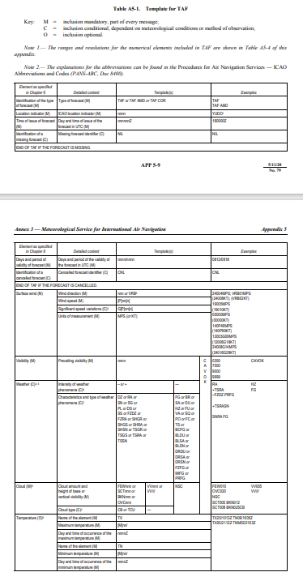
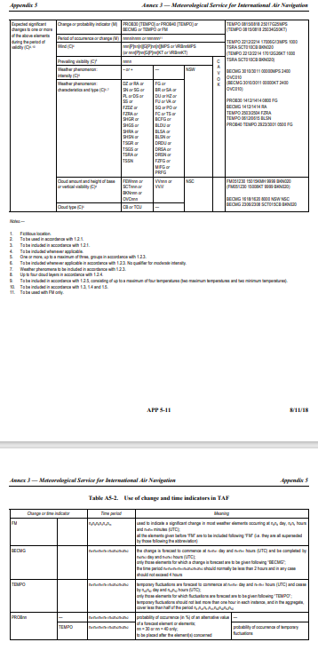
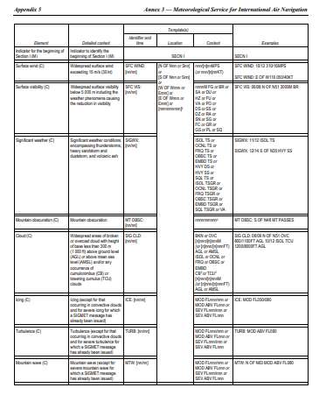
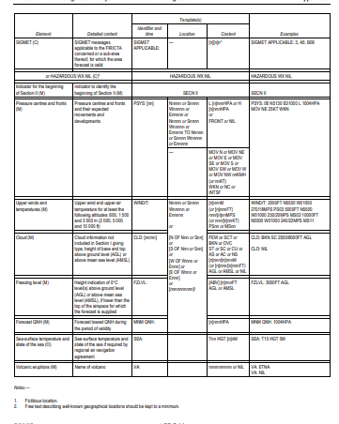
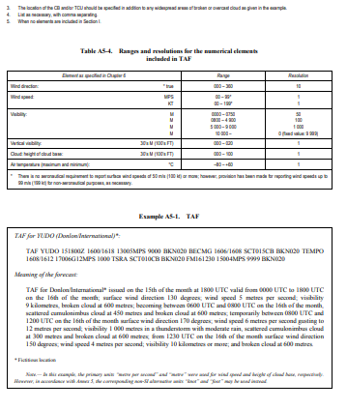
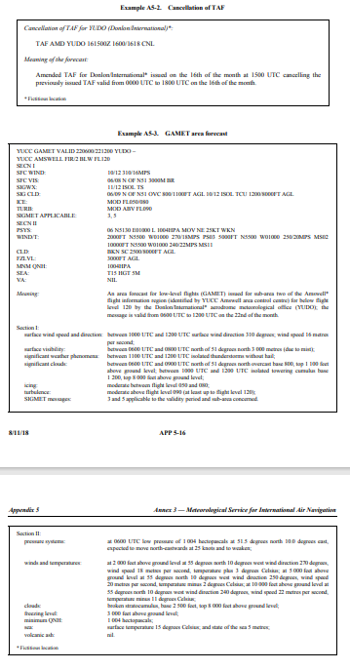

APPENDIX 6.

TECHNICAL SPECIFICATIONS RELATED TO SIGMET AND AIRMET INFORMATION, AERODROME WARNINGS AND WIND SHEAR WARNINGS AND ALERTS

Specifications related to SIGMET information
- Format of SIGMET messages
- The content and order of elements in a SIGMET message shall be in accordance with the template shown in Table A6-1A.
- Messages containing SIGMET information shall be identified as: “SIGMET”.
- The sequence number referred to in the template in Table A6-1A shall correspond with the number of SIGMET messages issued for the flight information region (FIR) since 0001 UTC on the day concerned. The meteorological watch offices whose area of responsibility encompasses more than one FIR and/or control area (CTA) shall issue separate SIGMET messages for each FIR and/or CTA within their area of responsibility.
- In accordance with the template in Table A6-1A, only one of the following phenomena shall be included in a SIGMET message, using the abbreviations as indicated below:
At cruising levels (irrespective of altitude):

thunderstorm
— obscured | OBSC TS
— embedded | EMBD TS
— frequent | FRQ TS
— squall line | SQL TS
— obscured with hail | OBSC TSGR
— embedded with hail | EMBD TSGR
— frequent, with hail | FRQ TSGR
— squall line with hail | SQL TSGR
tropical cyclone
— tropical cyclone with 10-minute mean surface wind speed of 17 m/s (34 kt) or more | TC (+ cyclone name)
turbulence
— severe turbulence | SEV TURB
icing
— severe icing  — severe icing due to  freezing rain | SEV ICE  SEV ICE (FZRA)
mountain wave
— severe mountain wave | SEV MTW
duststorm

— heavy duststorm | HVY DS
sandstorm
— heavy sandstorm | HVY SS
volcanic ash
— volcanic ash | VA (+ volcano name, if known)
radioactive cloud | RDOACT CLD
- SIGMET information shall not contain unnecessary descriptive material. In describing the weather phenomena for which the SIGMET is issued, no descriptive material additional to that given in (4) shall be included. SIGMET information concerning thunderstorms or a tropical cyclone shall not include references to associated turbulence and icing.
- As of 5 November 2020, SIGMET information shall be disseminated in IWXXM GML form in addition to the dissemination of SIGMET information in accordance with (1).
- Dissemination of SIGMET messages
- SIGMET messages shall be disseminated to meteorological watch offices, WAFCs and to other meteorological offices in accordance with regional air navigation agreement. SIGMET messages for volcanic ash shall also be disseminated to volcanic ash advisory centres.
- SIGMET messages shall be disseminated to international OPMET databanks and the centres designated by regional air navigation agreement for the operation of aeronautical fixed service Internet-based services, in accordance with regional air navigation agreement.

Specifications related to AIRMET information
- Format of AIRMET messages
- The content and order of elements in an AIRMET message shall be in accordance with the template shown in Table A6-1A.
- The sequence number referred to in the template in Table A6-1A shall correspond with the number of AIRMET messages issued for the FIR since 0001 UTC on the day concerned. The meteorological watch offices whose area of responsibility encompasses more than one FIR and/or CTA shall issue separate AIRMET messages for each FIR and/or CTA within their area of responsibility.
- The FIR shall be divided in sub-areas, as necessary.
- In accordance with the template in Table A6-1A, only one of the following phenomena shall be included in an AIRMET message, using the abbreviations as indicated below:

At cruising levels below flight level 100 (or below flight level 150 in mountainous areas, or higher, where necessary):

— surface wind speed
– widespread mean surface | SFC WIND
wind speed above 15 m/s (30 kt) | (+ wind, direction, speed and units)
— surface visibility
– widespread areas affected by reduction of visibility to less than 5 000 m, including the weather phenomenon causing the reduction of visibility | SFC VIS  (+ visibility)  (+ one of the following weather phenomena or combinations  thereof: BR, DS, DU, DZ, FC, FG, FU, GR, GS, HZ, PL, PO,  RA, SA, SG, SN, SQ, SS or VA)
— thunderstorms
– isolated thunderstorms without hail | ISOL TS
– occasional thunderstorms without hail | OCNL TS
– isolated thunderstorms with hail | ISOL TSGR
– occasional thunderstorms with hail | OCNL TSGR
— mountain obscuration
– mountains obscured | MT OBSC
— cloud
– widespread areas of broken or overcast cloud with height of base less than 300 m (1 000 ft)
above ground level:
– broken | BKN CLD (+ height of the base and top and units)
– overcast | OVC CLD (+ height of the base and top and units)
– cumulonimbus clouds which are:
– isolated | ISOL CB
– occasional | OCNL CB
– frequent | FRQ CB
– towering cumulus clouds which are:
– isolated | ISOL TCU
– occasional | OCNL TCU
– frequent | FRQ TCU
— icing
– moderate icing (except for icing in convective clouds) | MOD ICE
— turbulence
– moderate turbulence (except for turbulence in convective clouds) | MOD TURB
— mountain wave
– moderate mountain wave | MOD MTW

- AIRMET information shall not contain unnecessary descriptive material. In describing the weather phenomena for which the AIRMET is issued, no descriptive material additional to that given in (4) shall be included. AIRMET information concerning thunderstorms or cumulonimbus clouds shall not include references to associated turbulence and icing.
- As of 5 November 2020, AIRMET information shall be disseminated in IWXXM GML form in addition to the dissemination of AIRMET information in accordance with (1).

Detailed criteria related to SIGMET and AIRMET messages and special air-reports (uplink)
- Turbulence shall be considered:
- severe when the peak value of EDR equals or exceeds 0.45; and
- moderate when the peak value of EDR is equal to or above 0.20 and below 0.45.

Specifications related to aerodrome warnings
- Format and dissemination of aerodrome warnings
- The aerodrome warnings shall be issued in accordance with the template in Table A6-2 where required by operators or aerodrome services and shall be disseminated in accordance with local arrangements to those concerned.
- The sequence number referred to in the template in Table A6-2 shall correspond with the number of aerodrome warnings issued for the aerodrome since 0001 UTC on the day concerned.

Specifications related to wind shear warnings
- Format and dissemination of wind shear warnings and alerts
- The wind shear warnings shall be issued in accordance with the template in Table A6-3 and shall be disseminated in accordance with local arrangements to those concerned.
- The sequence number referred to in the template in Table A6-3 shall correspond with the number of wind shear warnings issued for the aerodrome since 0001 UTC on the day concerned.
- The wind shear alerts shall be disseminated from automated, ground-based, wind shear remote-sensing or detection equipment in accordance with local arrangements to those concerned.
- Where information from ground-based, wind shear detection or remote-sensing equipment is used to prepare a wind shear alert, the alert shall, if practicable, relate to specific sections of the runway and distances along the approach path or take-off path as agreed between the meteorological authority, the appropriate ATS authority and the operators concerned.

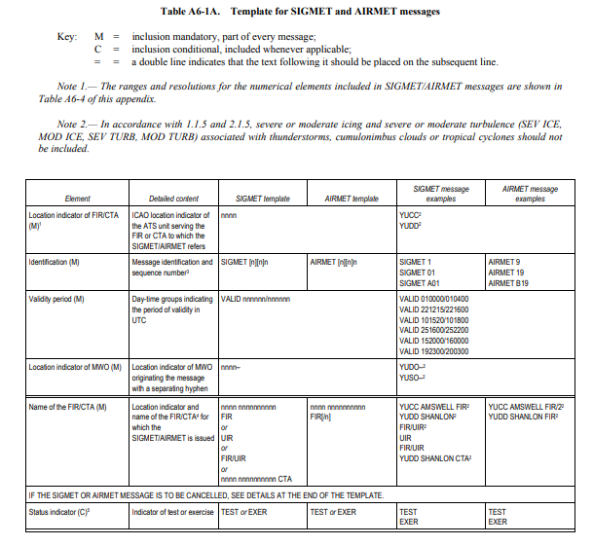
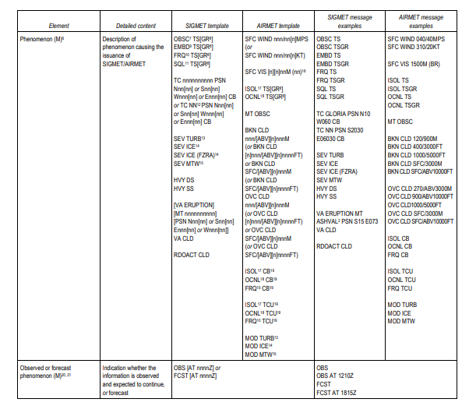
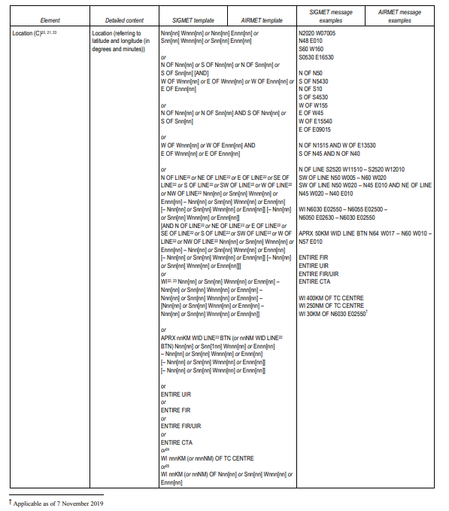
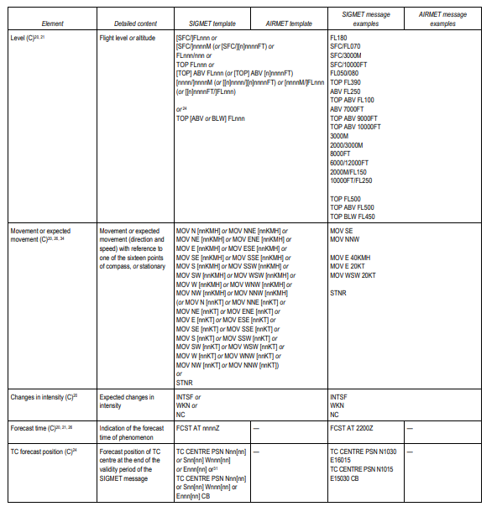
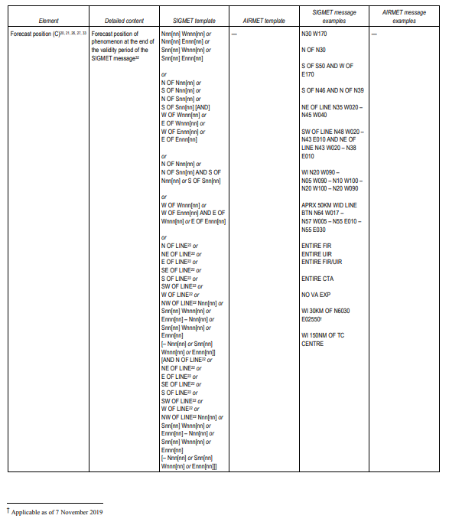
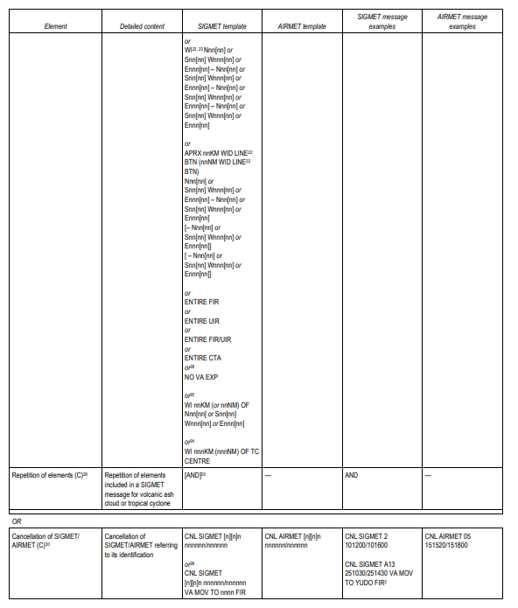
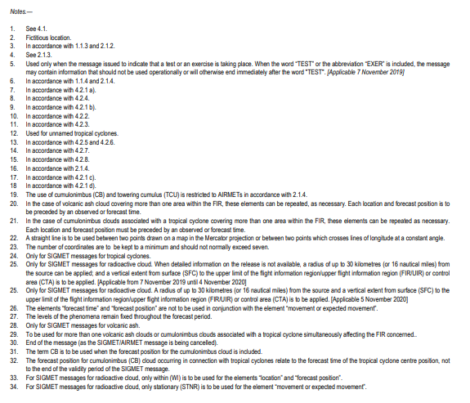
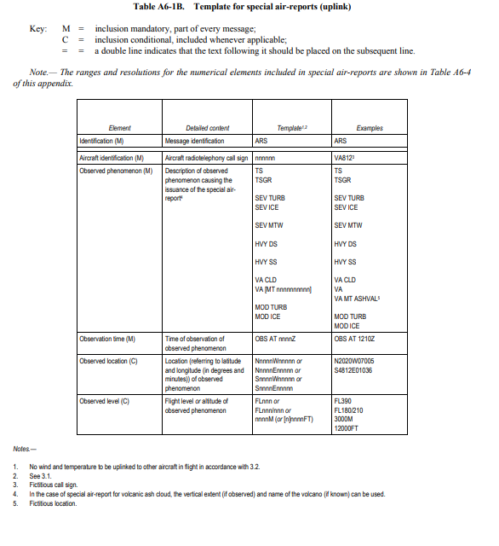
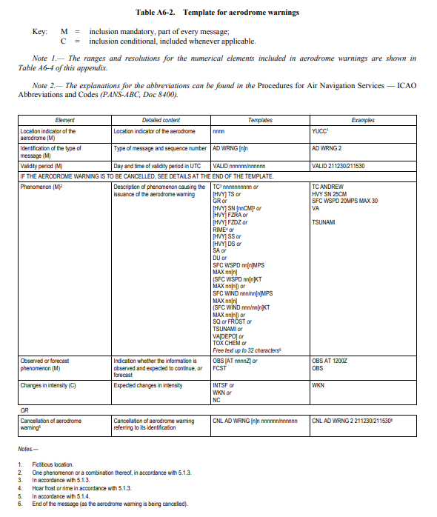
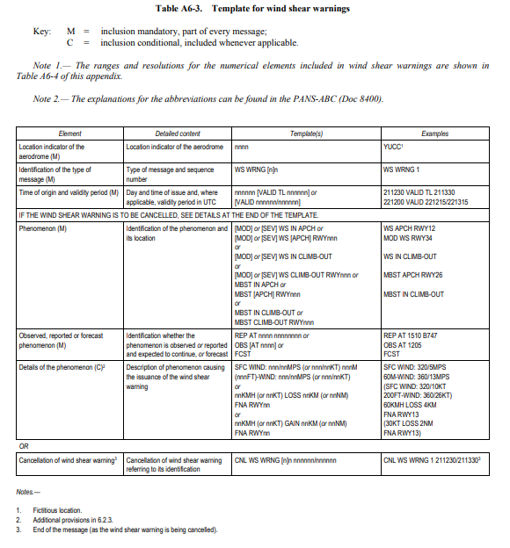
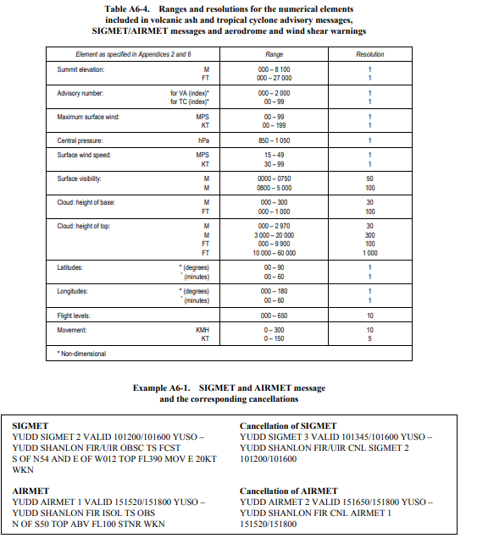
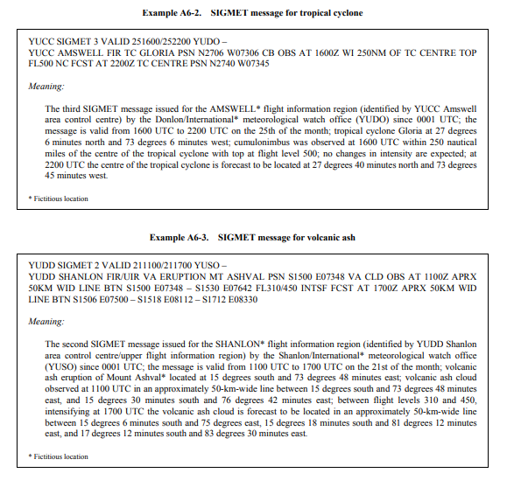
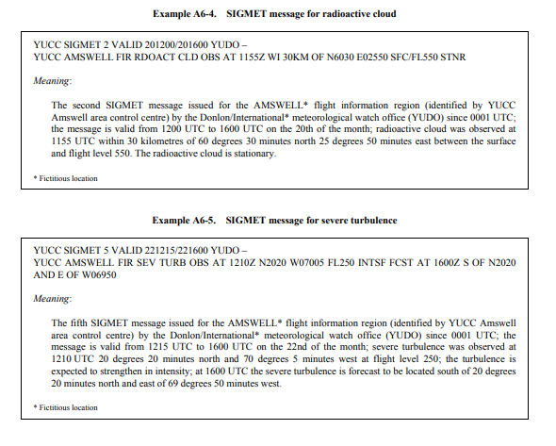
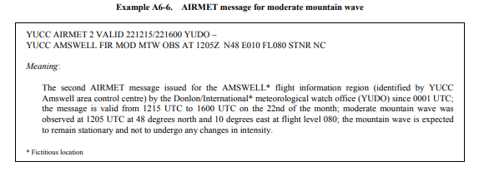

APPENDIX 8.

TECHNICAL SPECIFICATIONS RELATED TO SERVICE FOR OPERATORS AND FLIGHT CREW MEMBERS

Means of supply and format of meteorological information
- Meteorological information shall be supplied to operators and flight crew members by one or more of the following, as agreed between the meteorological authority and the operator concerned, and with the order shown below not implying priorities:
- written or printed material, including specified charts and forms;
- data in digital form;
- briefing;
- consultation;
- display; or
- in lieu of 1) to 6), by means of an automated pre-flight information system providing self-briefing and flight documentation facilities while retaining access by operators and aircrew members to consultation, as necessary, with the aerodrome meteorological office. SThe meteorological authority, in consultation with the operator, shall determine:
- the type and format of meteorological information to be supplied; and
- methods and means of supplying that information.

Specifications related to information for pre-flight planning and in-flight replanning
- Format of upper-air gridded information
Upper-air gridded information supplied by the world area forecast centres (WAFCs) for pre-flight and in-flight replanning shall be in the GRIB code form.
- Format of information on significant weather
Information on significant weather supplied by WAFCs for pre-flight planning and in-flight replanning shall be in the BUFR code form.

Specifications related to flight documentation
- Presentation of information
- The flight documentation related to forecasts of upper wind and upper-air temperature and SIGWX phenomena shall be presented in the form of charts. For low-level flights, alternatively, GAMET area forecasts shall be used.
- METAR and SPECI (including trend forecasts as issued in accordance with regional air navigation agreement), TAF, GAMET, SIGMET and AIRMET, volcanic ash, tropical cyclone and space weather advisory information shall be presented in accordance with the templates in Appendices 1, 2, 3, 5 and 6. Such meteorological information received from other meteorological offices shall be included in flight documentation without change.
- Charts in flight documentation
- Characteristics of charts
- Meteorological information included in flight documentation shall be represented as follows:
- winds on charts shall be depicted by arrows with feathers and shaded pennants on a sufficiently dense grid;
- temperatures shall be depicted by figures on a sufficiently dense grid;
- wind and temperature data selected from the data sets received from a world area forecast centre shall be depicted in a sufficiently dense latitude/longitude grid; and
- wind arrows shall take precedence over temperatures and either shall take precedence over chart background
- Set of charts to be provided
- The minimum number of charts for flights between flight level 250 and flight level 630 shall include a high-level SIGWX chart (flight level 250 to flight level 630) and a forecast 250 hPa wind and temperature chart. The actual charts provided for pre-flight and in-flight planning and for flight documentation shall be as agreed between meteorological authorities and users concerned.
- Charts to be provided shall be generated from the digital forecasts provided by the WAFCs whenever these forecasts cover the intended flight path in respect of time, altitude and geographical extent, unless otherwise agreed between the meteorological authority and the operator concerned.
- Height indications
- In flight documentation, height indications shall be given as follows:
- all references to en-route meteorological conditions, such as height indications of upper winds, turbulence or bases and tops of clouds, shall preferably be expressed in flight levels; they may also be expressed in pressure, altitude or, for low-level flights, height above ground level; and
- all references to aerodrome meteorological conditions, such as height indications of the bases of clouds, shall be expressed in height above the aerodrome elevation.

Specifications related to automated pre-flight information systems for briefing, consultation, flight planning and flight documentation
- Access to the systems
Automated pre-flight information systems providing self-briefing facilities shall provide for access by operators and flight crew members to consultation, as necessary, with an aerodrome meteorological office by telephone or other suitable telecommunications means.
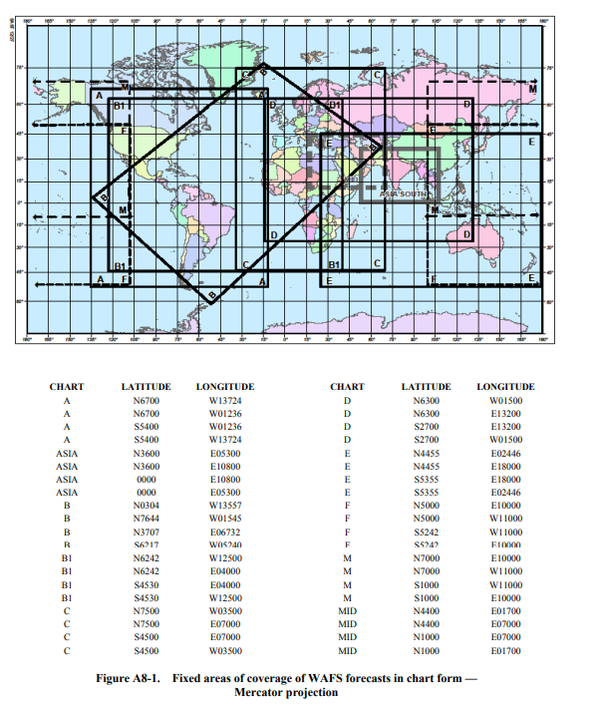
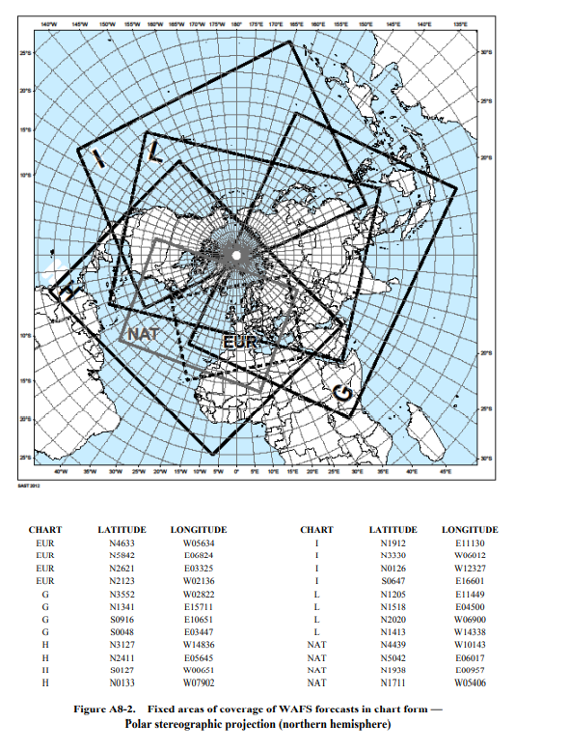
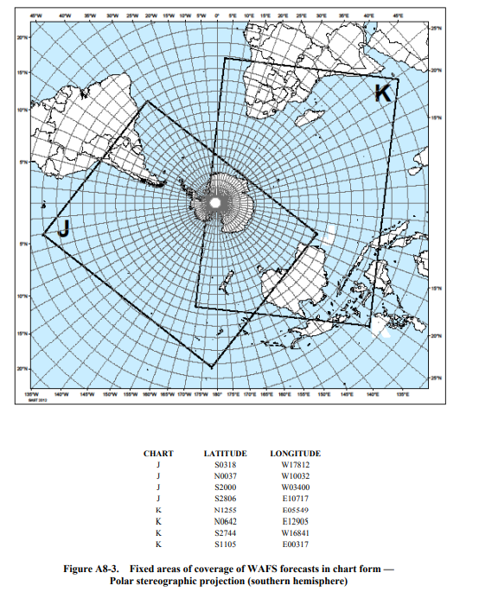

APPENDIX 9.

TECHNICAL SPECIFICATIONS RELATED TO INFORMATION FOR AIR TRAFFIC SERVICES, SEARCH AND RESCUE SERVICES AND AERONAUTICAL INFORMATION SERVICES

Information to be provided for air traffic services units
- List of information for the aerodrome control tower
The following meteorological information shall be supplied, as necessary, to an aerodrome control tower by its associated aerodrome meteorological office:
- local routine reports, local special reports, METAR, SPECI, TAF, trend forecasts and amendments thereto, for the aerodrome concerned;
- SIGMET and AIRMET information, wind shear warnings and alerts and aerodrome warnings;
- any additional meteorological information agreed upon locally, such as forecasts of surface wind for the determination of possible runway changes;
- information received on volcanic ash cloud, for which a SIGMET has not already been issued, as agreed between the meteorological and ATS authorities concerned; and
- information received on pre-eruption volcanic activity and/or a volcanic eruption as agreed between the meteorological and ATS authorities concerned.
- List of information for the approach control unit
The following meteorological information shall be supplied, as necessary, to an approach control unit by its associated aerodrome meteorological office:
- local routine reports, local special reports, METAR, SPECI, TAF, trend forecasts and amendments thereto, for the aerodrome(s) with which the approach control unit is concerned;
- SIGMET and AIRMET information, wind shear warnings and alerts and appropriate special air-reports for the airspace with which the approach control unit is concerned and aerodrome warnings;
- any additional meteorological information agreed upon locally;
- information received on volcanic ash cloud, for which a SIGMET has not already been issued, as agreed between the meteorological and ATS authorities concerned; and
- information received on pre-eruption volcanic activity and/or a volcanic eruption as agreed between the meteorological and ATS authorities concerned.
- List of information for the area control centre and flight information centre
The following meteorological information shall be supplied, as necessary, to an area control centre or a flight information centre by its associated meteorological watch office:
- METAR and SPECI, including current pressure data for aerodromes and other locations, TAF and trend forecasts and amendments thereto, covering the flight information region (FIR) or the control area (CTA) and, if required by the flight information centre (FIC) or area control centre (ACC), covering aerodromes in neighbouring FIRs, as determined by regional air navigation agreement;
- forecasts of upper winds, upper-air temperatures and significant en-route weather phenomena and amendments thereto, particularly those which are likely to make operation under visual flight rules impracticable, SIGMET and AIRMET information and appropriate special air-reports for the FIR or CTA and, if determined by regional air navigation agreement and required by the FIC or ACC, for neighbouring FIRs;
- any other meteorological information required by the FIC or ACC to meet requests from aircraft in flight; if the information requested is not available in the associated meteorological watch office (MWO), that office shall request the assistance of another meteorological office in supplying it;
- information received on volcanic ash cloud, for which a SIGMET has not already been issued, as agreed between the meteorological and ATS authorities concerned;
- information received concerning the release of radioactive material into the atmosphere, as agreed between the meteorological and ATS authorities concerned;
- tropical cyclone advisory information issued by a tropical cyclone advisory centre in its area of responsibility;
- volcanic ash advisory information issued by a volcanic ash advisory centre in its area of responsibility; and
- information received on pre-eruption volcanic activity and/or a volcanic eruption as agreed between the meteorological and ATS authorities concerned.
- Supply of information to aeronautical telecommunications stations
Where necessary for flight information purposes, current meteorological reports and forecasts shall be supplied to designated aeronautical telecommunication stations. A copy of such information shall be forwarded, if required, to the FIC or ACC.

Information to be provided for search and rescue services units
List of information Information to be supplied to rescue coordination centres shall include the meteorological conditions that existed in the last known position of a missing aircraft and along the intended route of that aircraft with particular reference to:
- significant en-route weather phenomena;
- cloud amount and type, particularly cumulonimbus; height indications of bases and tops;
- visibility and phenomena reducing visibility;
- surface wind and upper wind;
- state of ground, in particular, any snow cover or flooding;
- sea-surface temperature, state of the sea, ice cover if any and ocean currents, if relevant to the search area; and
- sea-level pressure data.

Information to be provided for aeronautical information services units
List of information The following information shall be supplied, as necessary, to an aeronautical information services unit:
- information on meteorological service for international air navigation, intended for inclusion in the aeronautical information publication(s) concerned;
- information necessary for the preparation of NOTAM or ASHTAM including, in particular, information on:
- the establishment, withdrawal and significant changes in operation of aeronautical meteorological services. This information is required to be provided to the aeronautical information services unit sufficiently in advance of the effective date to permit issuance of NOTAM in compliance with SASO Aeronautical Information Service Regulations;
- the occurrence of volcanic activity; and
- release of radioactive materials into the atmosphere, as agreed between the meteorological and appropriate civil aviation authorities concerned; and
- information necessary for the preparation of aeronautical information circulars including, in particular, information on:
- expected important changes in aeronautical meteorological procedures, services and facilities provided; and
- effect of certain weather phenomena on aircraft operations.

APPENDIX 10.

TECHNICAL SPECIFICATIONS RELATED TO REQUIREMENTS FOR AND USE OF COMMUNICATIONS

Specific requirements for communications
Required transit times of operational meteorological information Messages and bulletins containing operational meteorological information shall achieve transit times of less than 5 minutes, unless otherwise determined to be lower by regional air navigation agreement.

Use of aeronautical fixed service communications and the public internet
- Meteorological bulletins in alphanumeric format
- Heading of bulletins
Meteorological bulletins containing operational meteorological information to be transmitted via the aeronautical fixed service or the public Internet shall contain a heading consisting of:
- an identifier of four letters and two figures;
- the ICAO four-letter location indicator corresponding to the geographical location of the meteorological office originating or compiling the meteorological bulletin;
- a day-time group; and
- if required, a three-letter indicator.
- Transmission of bulletins containing operational meteorological information
Meteorological bulletins containing operational meteorological information shall be transmitted via the aeronautical fixed service (AFS).
- World area forecast system (WAFS) products
- Heading of bulletins containing WAFS products
Meteorological bulletins containing WAFS products in digital form to be transmitted via aeronautical fixed service or the public Internet shall contain a heading as given in a) (1).

Use of aeronautical mobile service communications
- Content and format of meteorological messages
- The content and format of reports, forecasts and SIGMET information transmitted to aircraft shall be consistent with the provisions of Chapters 4, 6 and 7 of this Regulations.
- The content and format of air-reports transmitted by aircraft shall be consistent with the provisions of Chapter 5 of this Regulations and the Procedures for Air Navigation Services — Air Traffic Management (PANS-ATM, Doc 4444), Appendix 1.
- Content and format of meteorological bulletins
The substance of a meteorological bulletin transmitted via the aeronautical mobile service shall remain unchanged from that contained in the bulletin as originated.

Use of aeronautical data link service — D-VOLMET
- Detailed content of meteorological information available for D-VOLMET
- The aerodromes for which METAR, SPECI and TAF are to be available for uplink to aircraft in flight shall be determined by regional air navigation agreement.
- The flight information regions (FIRs) for which SIGMET and AIRMET messages are to be available for uplink to aircraft in flight shall be determined by regional air navigation agreement.
- Format of information to be available for D-VOLMET
The content and format of reports, forecasts and SIGMET and AIRMET information included in D-VOLMET shall be consistent with the provisions of Chapters 4, 6 and 7 of this Regulations.

Use of aeronautical broadcasting service — VOLMET broadcasts
- Detailed content of meteorological information to be included in VOLMET broadcasts
- The aerodromes for which METAR, SPECI and TAF are to be included in VOLMET broadcasts, the sequence in which they are to be transmitted and the broadcast time shall be determined by regional air navigation agreement.
- The FIRs for which SIGMET messages are to be included in scheduled VOLMET broadcasts shall be determined by regional air navigation agreement. Where this is done, the SIGMET message shall be transmitted at the beginning of the broadcast or of a five-minute time block.
- Format of information to be included in VOLMET broadcasts
The content and format of reports, forecasts and SIGMET information included in VOLMET broadcasts shall be consistent with the provisions of Chapters 4, 6 and 7 of this Regulations.

