**LUC TYTGAT, EASA**



Director, Strategy and Safety Management Directorate

Luc Tytgat is since 1st January 2015 Director of the Strategy and Safety Management Directorate of the European Union Aviation Safety Agency (EASA).

Luc Tytgat is in charge of raising safety intelligence as one of EASA’s key priorities and developing a better and more agile regulatory framework. Prior to EASA, Luc Tytgat was the Director of the Pan-European Single Sky Directorate at Eurocontrol since 2011, after having worked for 20 years in the field of air transport and space at the European Commission and 10 years in the Belgian Air Force.

Luc Tytgat also has a significant experience when dealing with matters related to the European Commission.

Luc Tytgat also initiated the GALILEO programme and established the EU competence in the space policy sector.

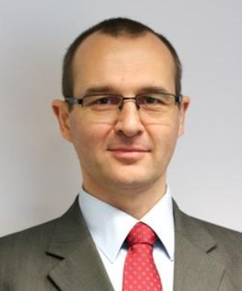**Yves Koning, EASA**International Cooperation Officer – Sub-Saharan Africa

Yves Koning joined the European Union Aviation Safety Agency (EASA) in September 2010.

He is charge of managing several technical assistance projects in Sub-Saharan Africa and ensures the coordination of the all the projects the European agency is managing in this region.

Prior to EASA, Yves Koning was a project manager for 5 years within a French consultancy company dealing with aviation safety. He mainly managed projects in western and central Africa, even if his tasks took him also to Zambia or South Asia. Beforehand he worked for 10 years in the field of human factors and delivered many trainings around the world from the Caribbean all the way to South East Asia and Oceania.

In the mid-90’s he lived in Central Africa for 2 years where he was the programme administrator/manager of an international NGO providing aviation services.