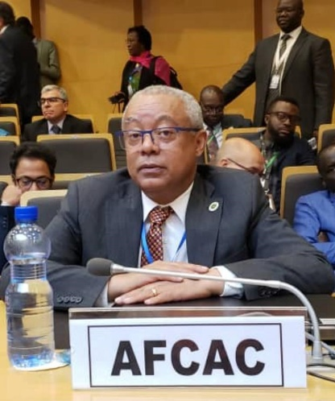

**Mr. Tefera Mekonnen TEFERA**

**Secretary General of the African Civil Aviation Commission (AFCAC) and CEO of the Executing Agency of the YD/the Single African Air Transport Market (SAATM).**

Mr. Tefera Mekonnen TEFERA has 40 years of experience working in the civil aviation sector spanning senior management positions at national and international organizations.

Prior to joining AFCAC, he had eight years of experience working as the Permanent Representative of Ethiopia to the International Civil Aviation Organization (ICAO), Montreal, Canada. During his tenure as Representative to ICAO, Mr. Tefera was actively engaged in the works of the AFI Group at ICAO and in sensitizing States through his effective participation in the development of the draft Common African Aviation Policy (AFCAP), the Abuja Safety Declaration and the AFI SECFAL Initiatives.

A holder of a B.A Economics degree. He has overseen the successful operationalization of the Executing Agency of the YD since he joined AFCAC as Director of Air Transport in 2015.

At AFCAC, he has championed the full implementation of the SAATM as evidenced in the rise of the SAATM States from 11 to 34 representing over 70% of intra Africa traffic. Mr. Tefera’s strong negotiation with partners has enabled AFCAC, among others to secure USD $ 6.7 Million grant from the African Development Bank for the implementation of the SAATM. He has also overseen financial and technical pledges from the EU and coordinated Stakeholders’ activities under the Joint Prioritized Action Plan all for the realization of a sustainable air transport industry in Africa.

He has signed with IATA and AFRAA agreements on IOSA/ISSA, and with ICAO Project Implementation to support SAATM States in the areas of Safety, Security and Environment Protection and hence the AU air transport liberalization agenda as part of the Agenda 2063.

Mr. Tefera is currently positioning AFCAC on a strategic path through a long term plan that is meant to ensure a sustainable air transport industry for the African continent that meets the current and future challenges in Safety, Security, Environment and Human Capacity.