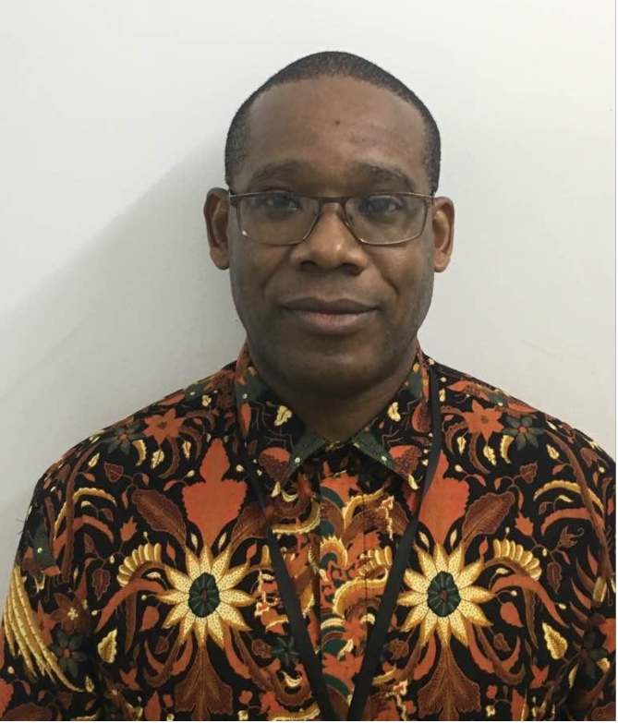

**Biography**

James Danga is the Aviation Safety Expert at the African Civil Aviation Commission (AFCAC) based in Dakar, Senegal. He is coordinator of the AFI-CIS Program with extensive experience in airline certification and surveillance. Previous experience includes serving ICAO TCB as Regional Safety Inspector at COSCAP-SADC in Gaborone, Botswana and the Civil Aviation Authority of Zimbabwe as Director Flight Safety & Standards. James has over 26 years of experience in aviation of which 18 years have been at the aviation regulatory/policy level.

He is a licensed aircraft maintenance engineer, ICAO CMA Subject Matter Expert (Airworthiness) and a qualified GSI Instructor – AIRWORTHINESS. He is a holder of several post graduate diplomas in airworthiness and aviation management.