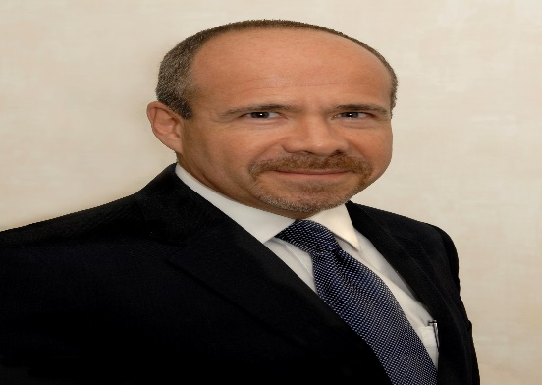

Capt. Miguel Ramos

Airline Pilot for over 18 years in Mexicana and LACSA, Capt. Ramos developed the first safety programme for the Costarrican airline that was merged into a regional air carrier for the Central America region. He holds a certificate in "Aviation Safety" from the University of Southern California and the "Civil Aviation Management" from the Singapore Aviation Academy.

In 1998 he was appointed as Director General of Civil Aviation in Costa Rica, responsible of restructuring the whole aeronautical authority. During his tenure, the Central American Aviation Safety Agency (ACSA) was established and new Costa Rican regulations were adopted later by the rest of the Central American States which now are known as MRACS.

From 2001 to 2004 he was appointed as the Representative of Costa Rica to the ICAO Council. In March 2005, he joined the ICAO Secretariat as a Technical Officer assigned to the Integrated Safety Management (ISM) Section of the Air Navigation Bureau. Since 2006, Capt. Ramos has conducted as lead instructor, more than 60 safety management training courses for States and service providers, worldwide. Training coordinator of the ICAO Aviation Safety Training Section from 2010-and from August, 2014-2017 assigned as technical officer to the RPAS programme. Currently he is the Chief Regional Cooperation and Technical Planning of the Air Navigation Bureau, responsible for the ICAO Global Aviation Safety Oversight System (GASOS) and the RSOO-Cooperative Platform.